**JMeter**

The Apache JMeter application is open-source software, a 100% pure Java application designed to load test functional behavior and measure performance. Apache JMeter may be used to test performance both on static and dynamic resources, Web dynamic applications. It can be used to simulate a heavy load on a server, group of servers, network or object to test its strength or to analyze overall performance under different load types.

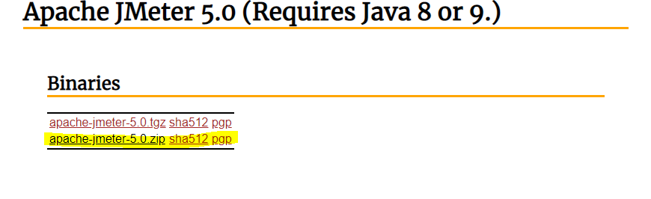**Download JMeter**

**Start JMeter**

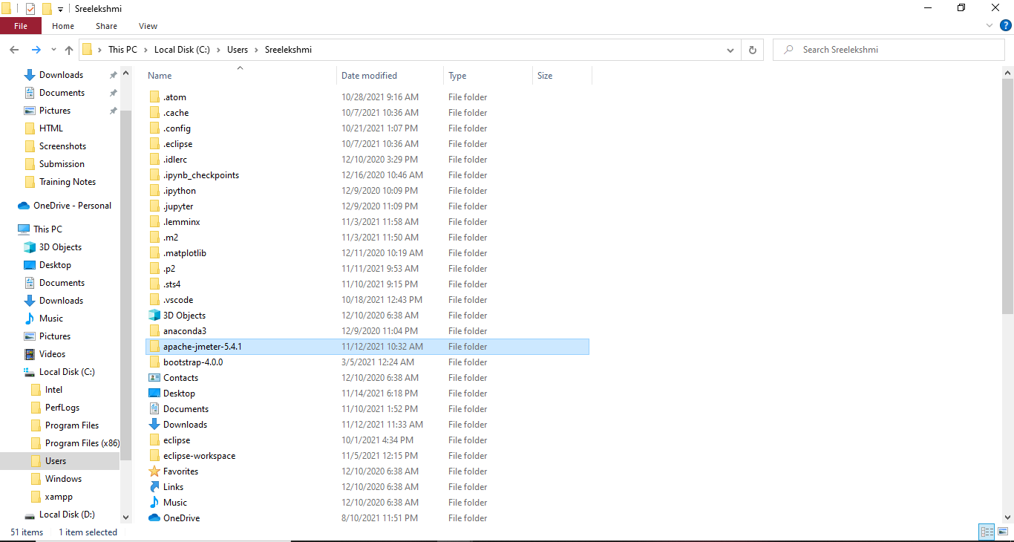To run the JMeter, go to the folder the /jmeter/bin and run jmeter windows batch file.

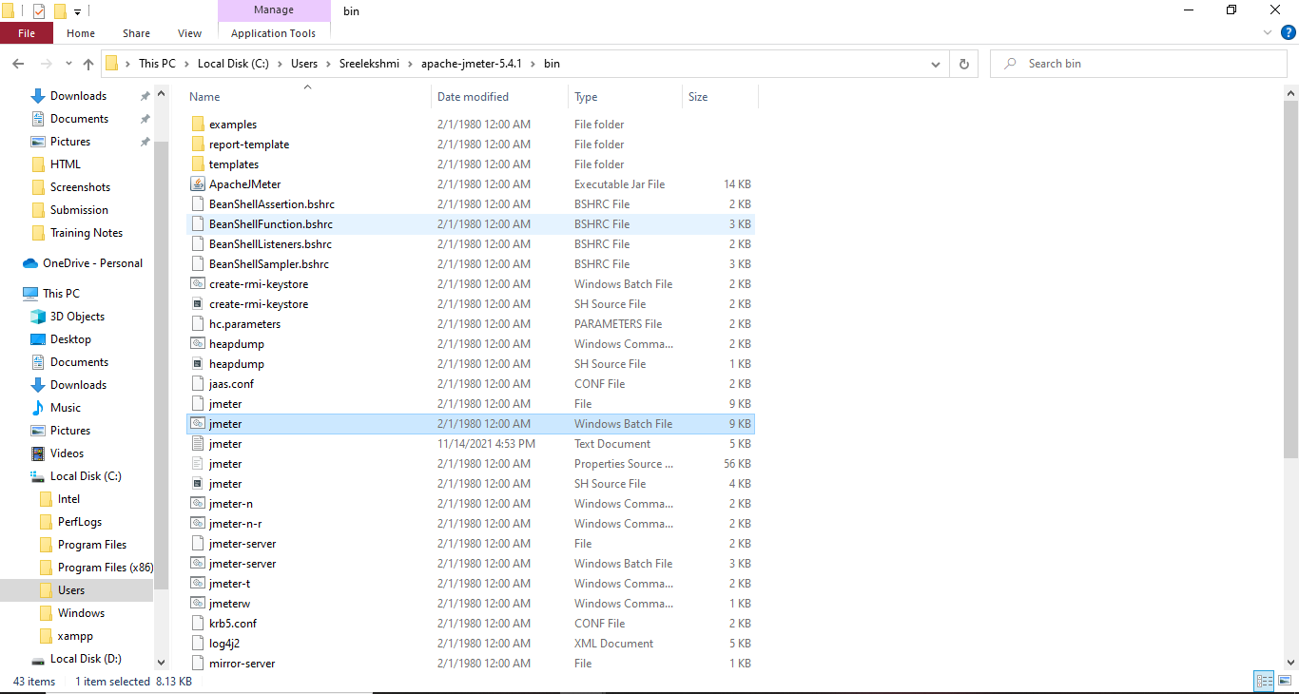

**Create a test plan for our web application’s load testing**

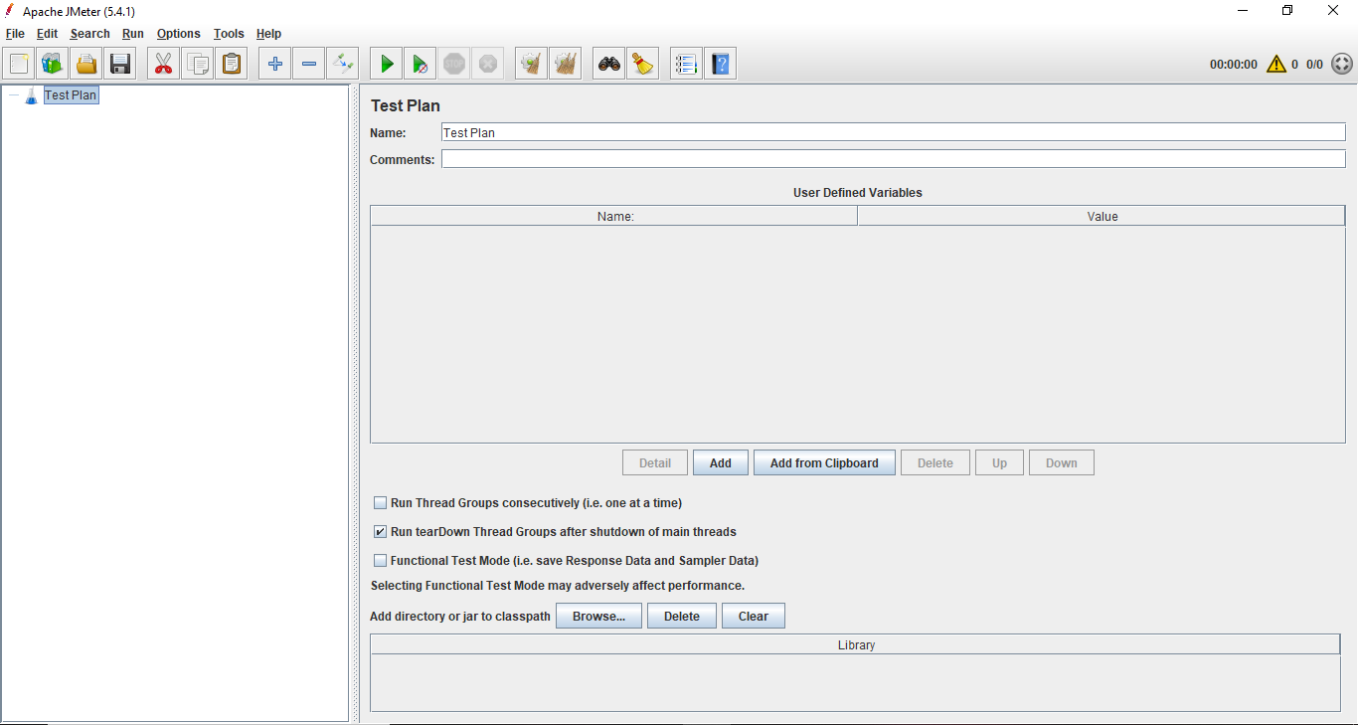

**Create Thread Group**

To create a thread group, navigate to ‘Right click Test Plan -> Add -> Threads -> Thread Group’.

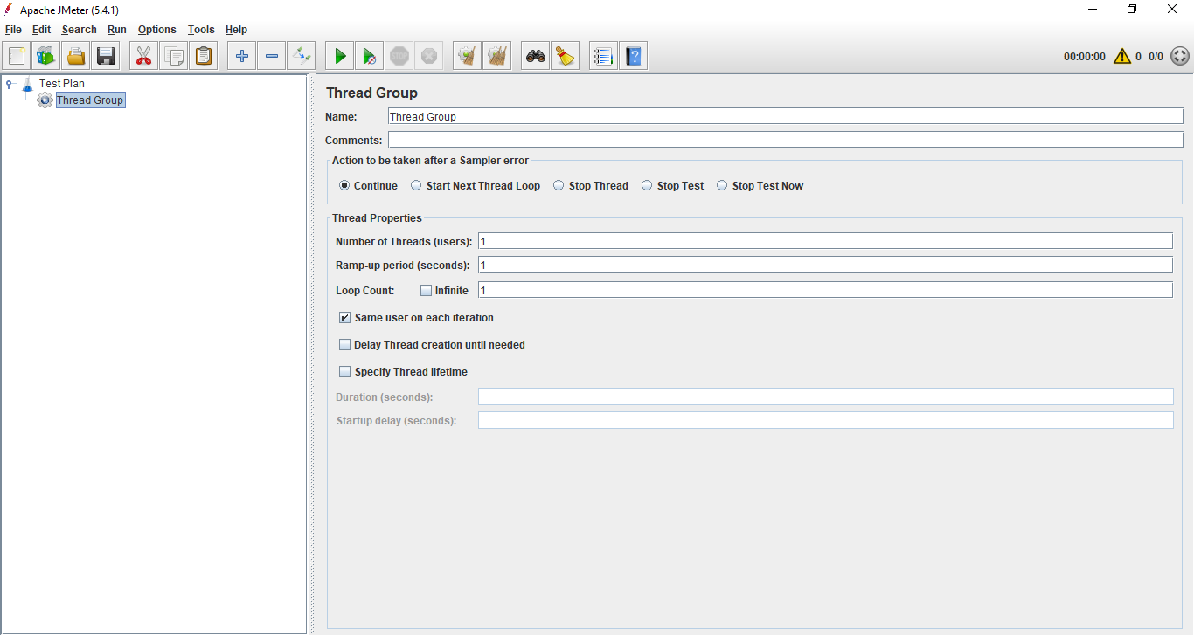

**Create HTTP Request**

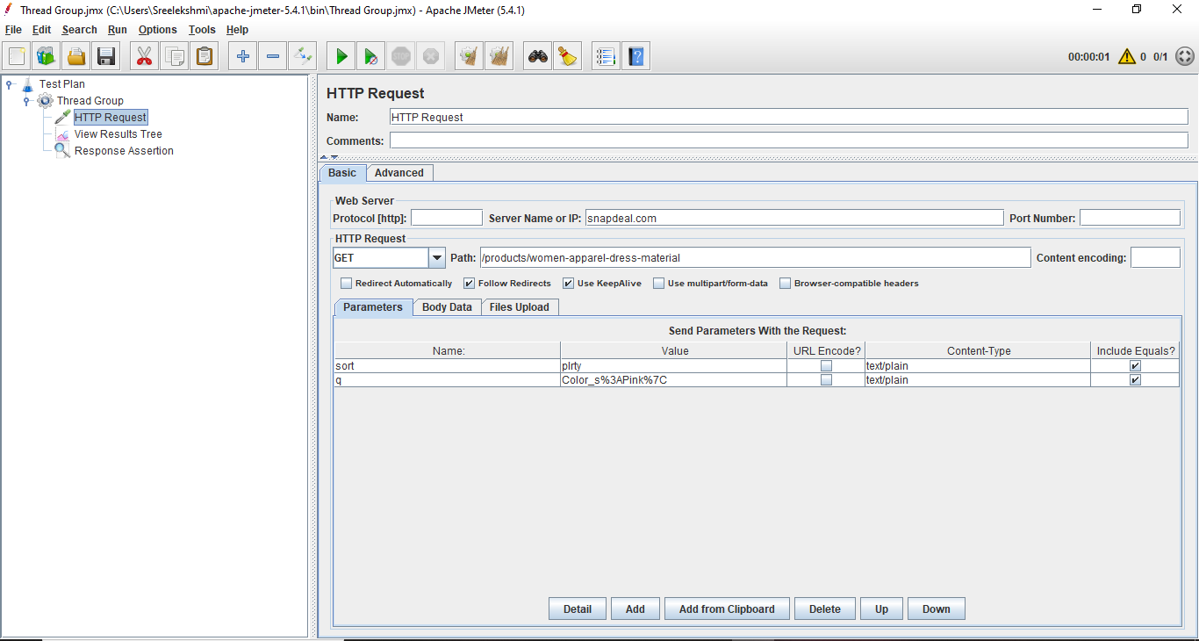To add HTTP request details, navigate to ‘Right click thread group -> Add -> Sampler -> HTTP Request’.

**Add Listener**

To see the results of test plan, add listener named “” by navigating to ‘Right click thread group -> Add -> Listener -> View Results Tree’.

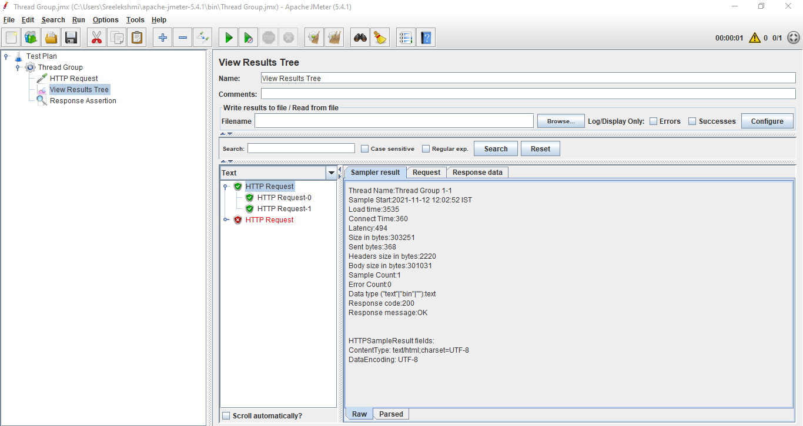

**JMeter Example-1**

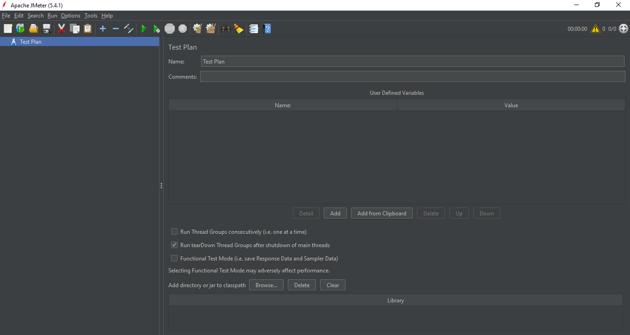Before Creating the Thread Group

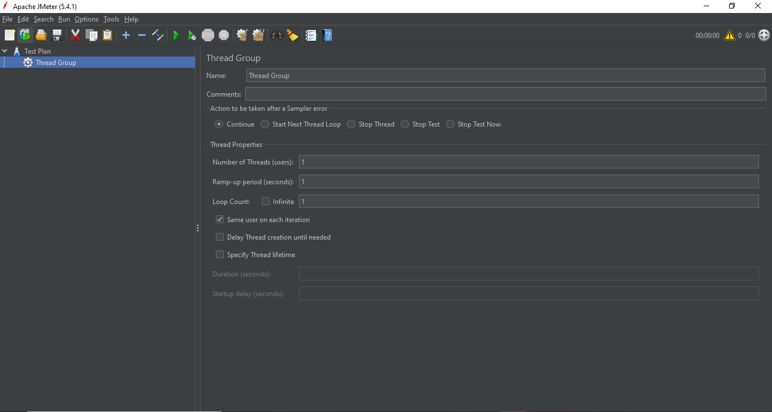After adding Thread Group

After adding the sampler

Result of the sampler after adding the Listener

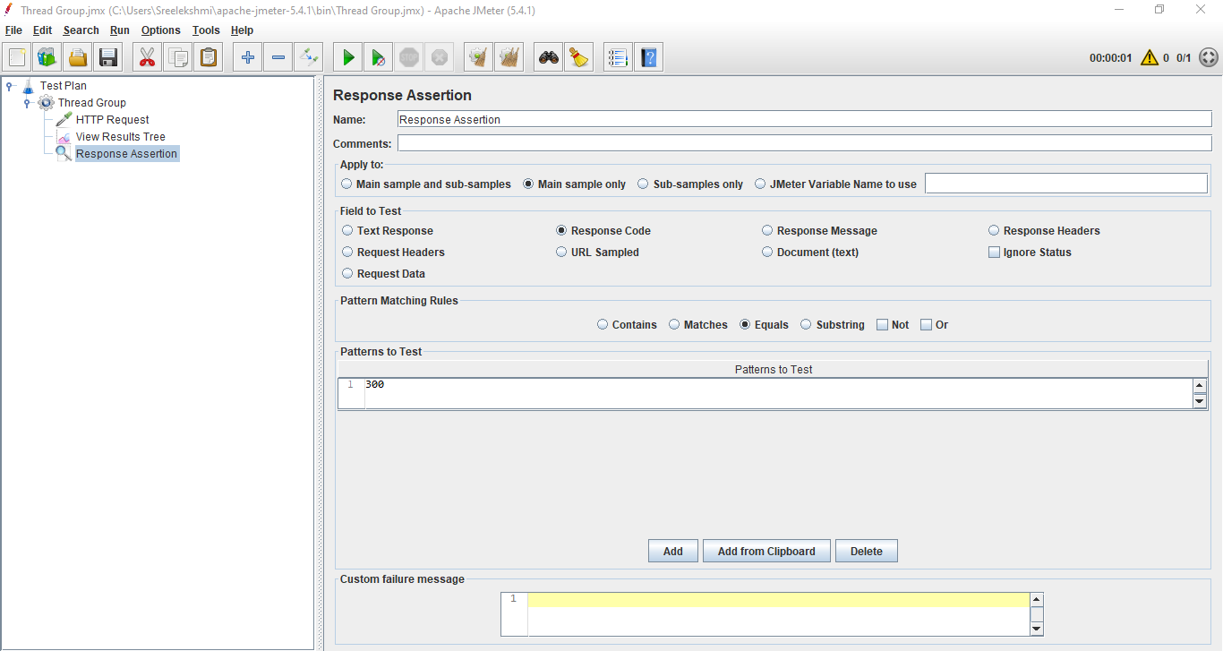After adding Response Assertion

Result after changing the Response code to 300

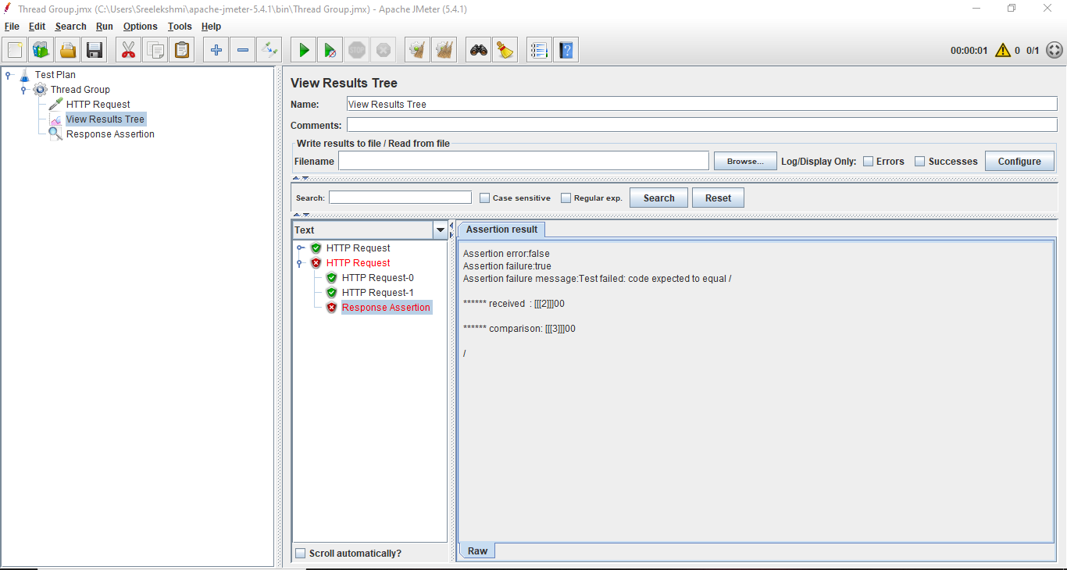

**JMeter Example_2**

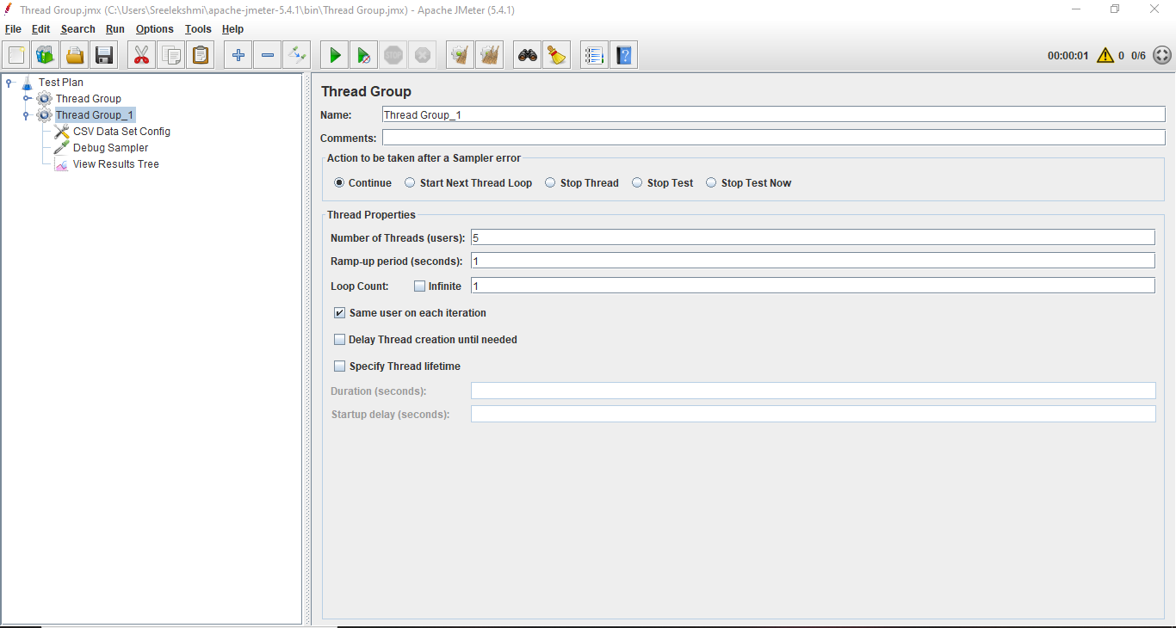After Adding Thread Group

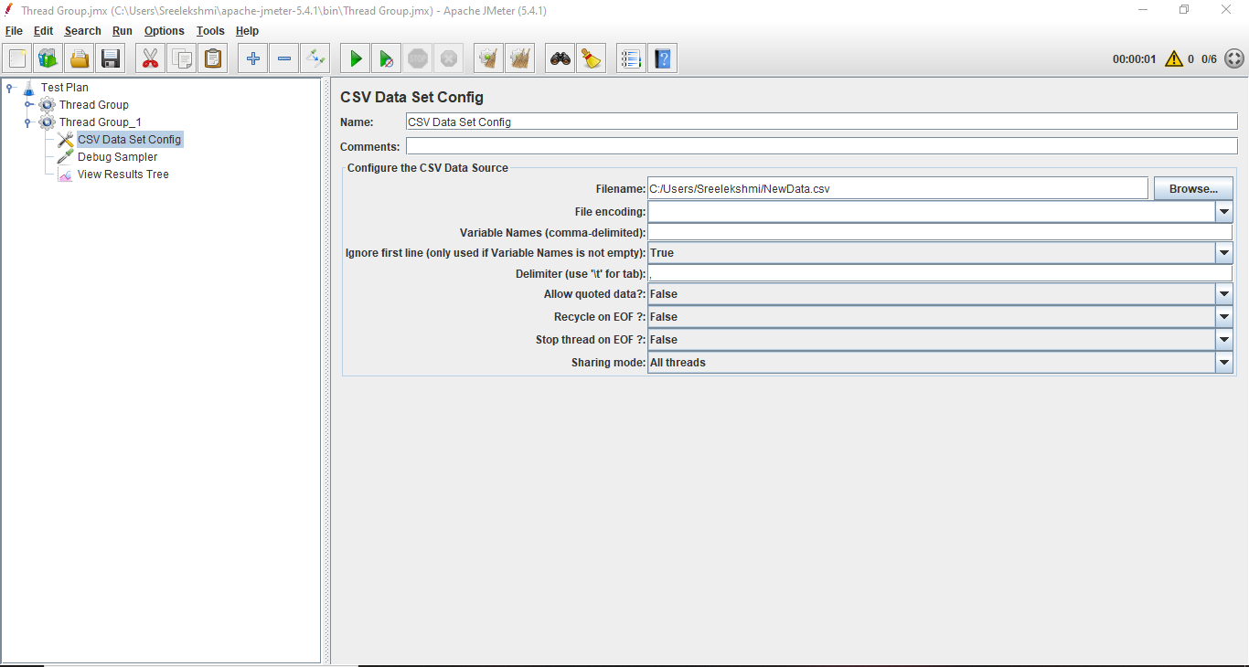CSV Data Set Config

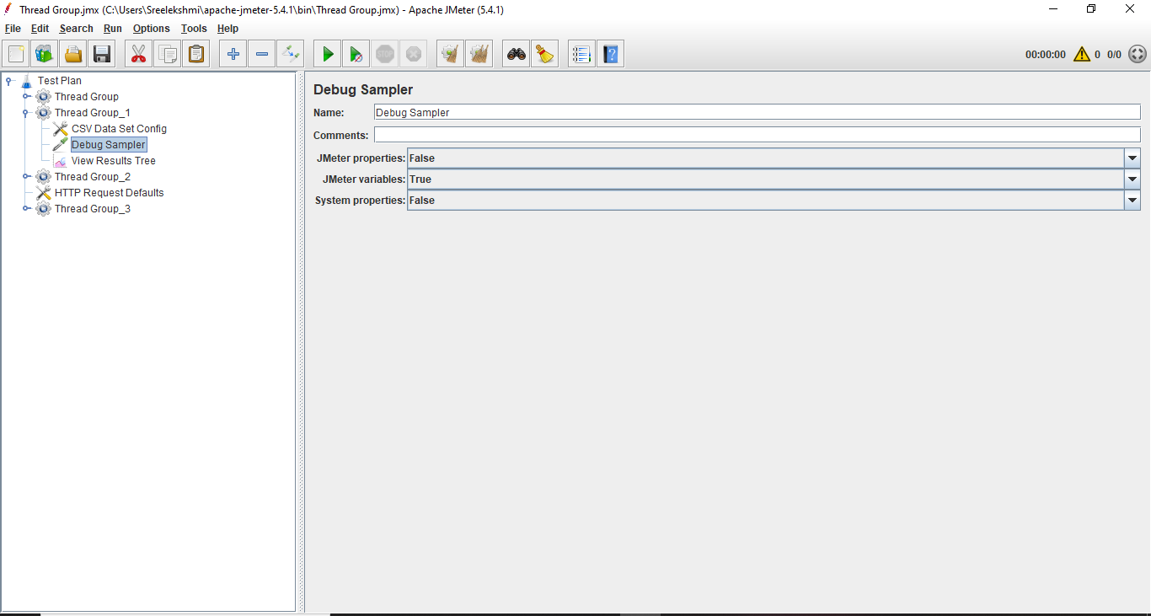After adding Debug Sampler

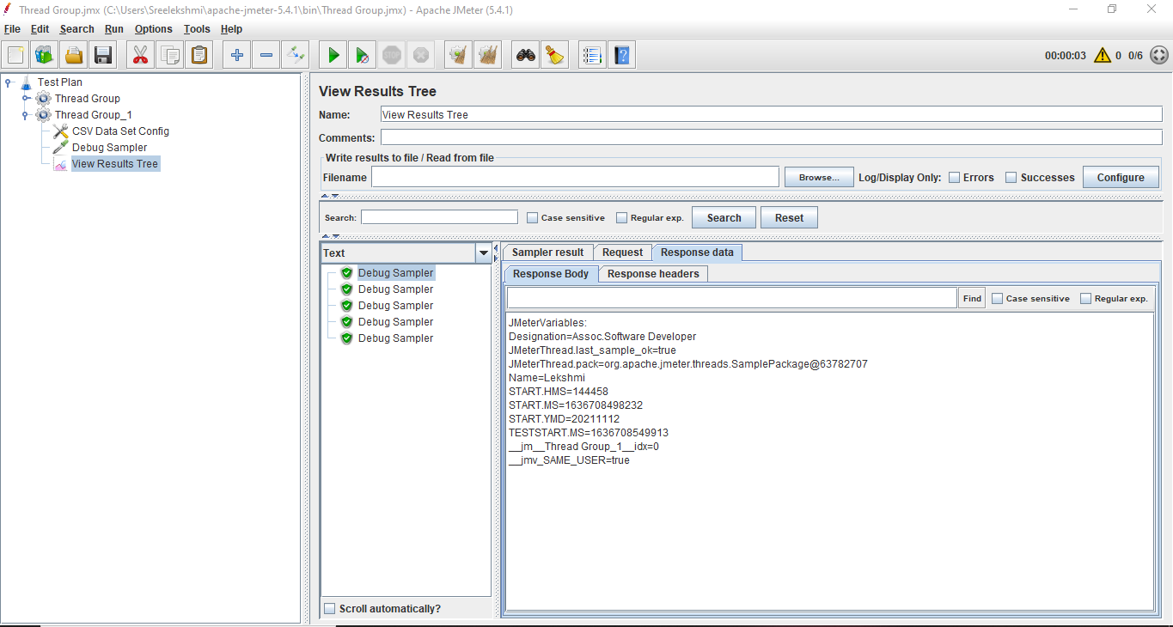Result of 1st Debug Sampler

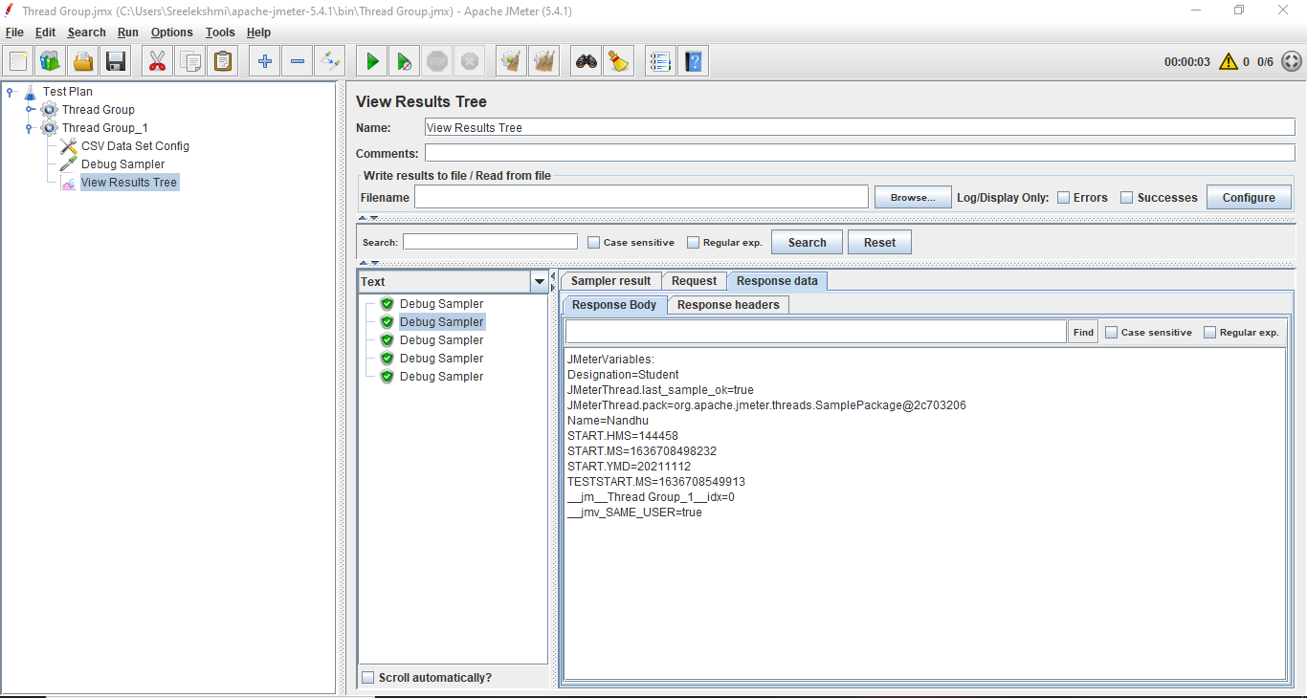Result of 2nd Debug Sampler

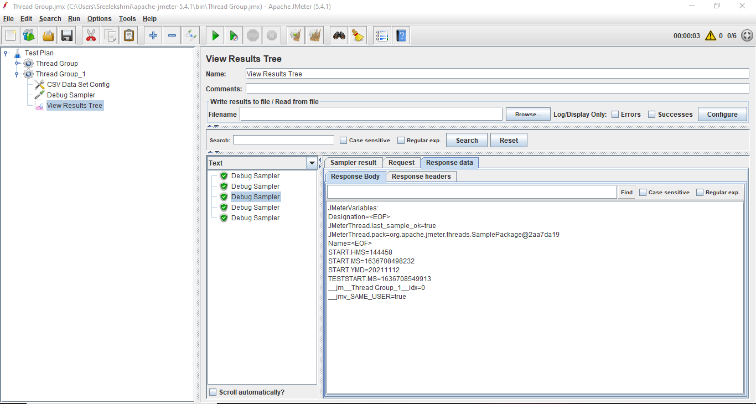Result of 3rd Debug Sampler

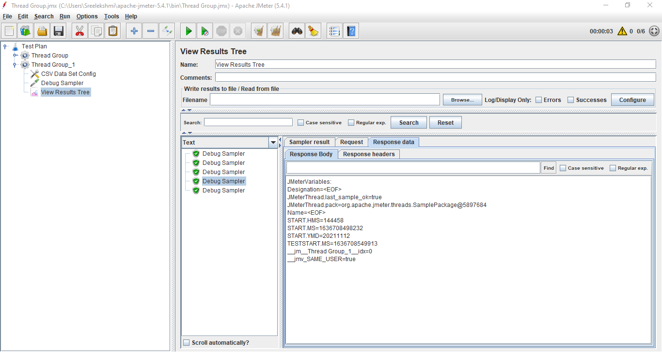Result of 4th Debug Sampler

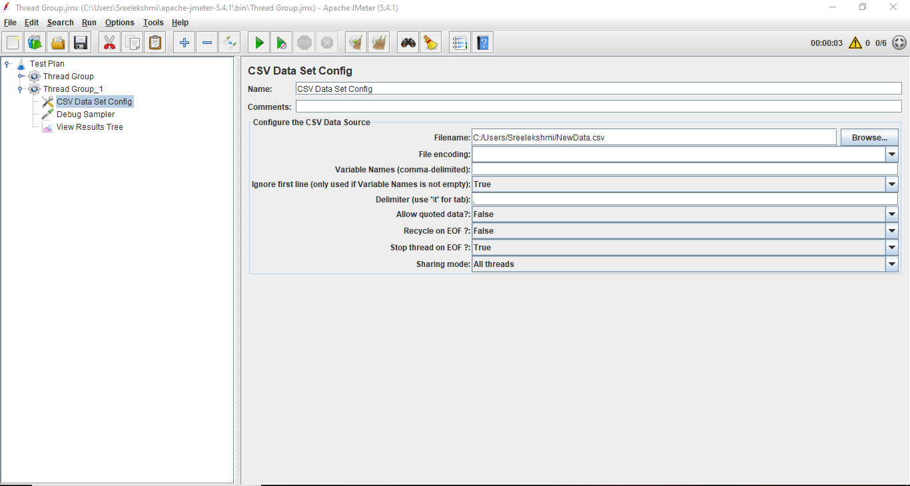After changed the CSV Data Set Config

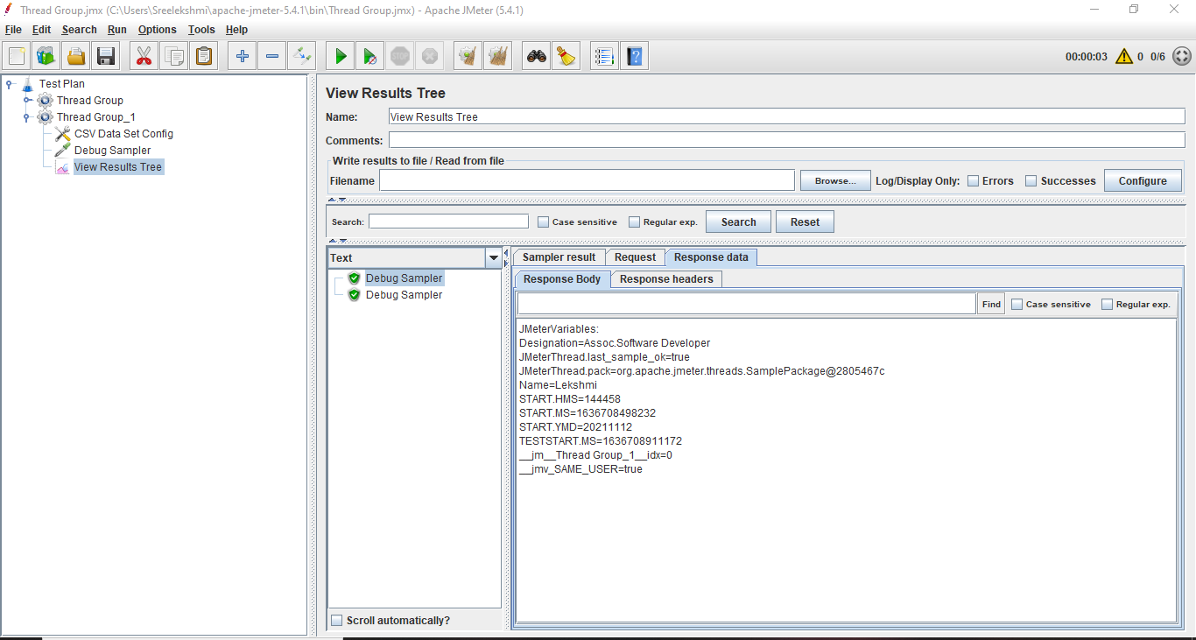Result after changing the values

**JMeter Example_3**

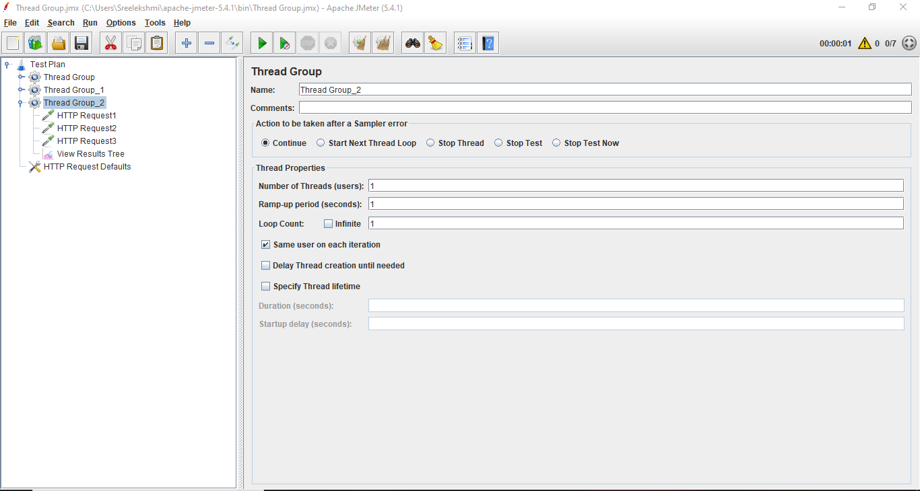After adding Thread group

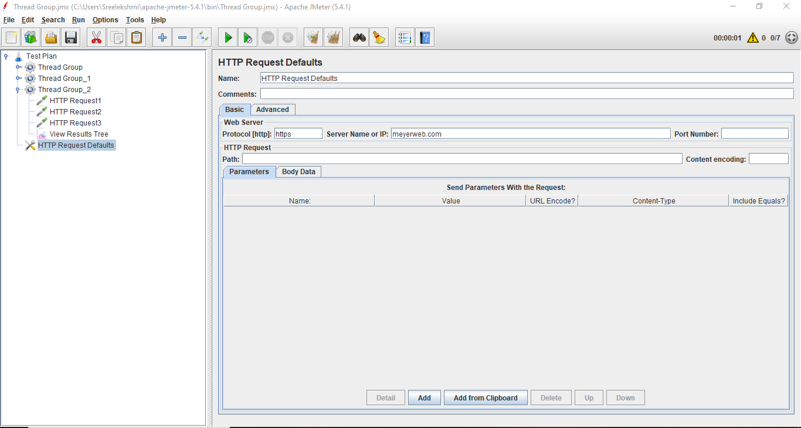After adding HTTP Request Defaults

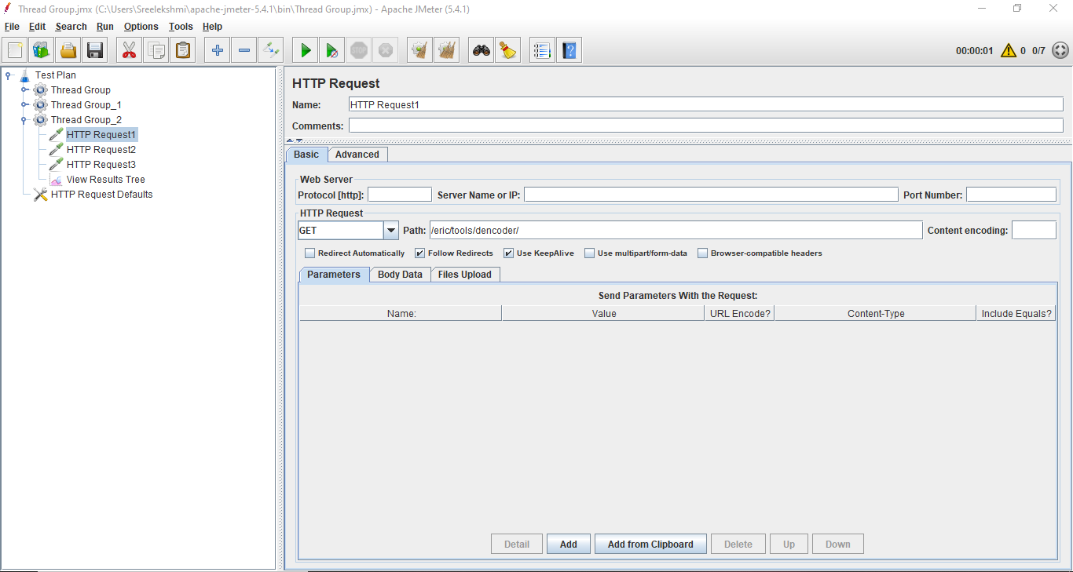After adding First Sampler HTTP Request 1

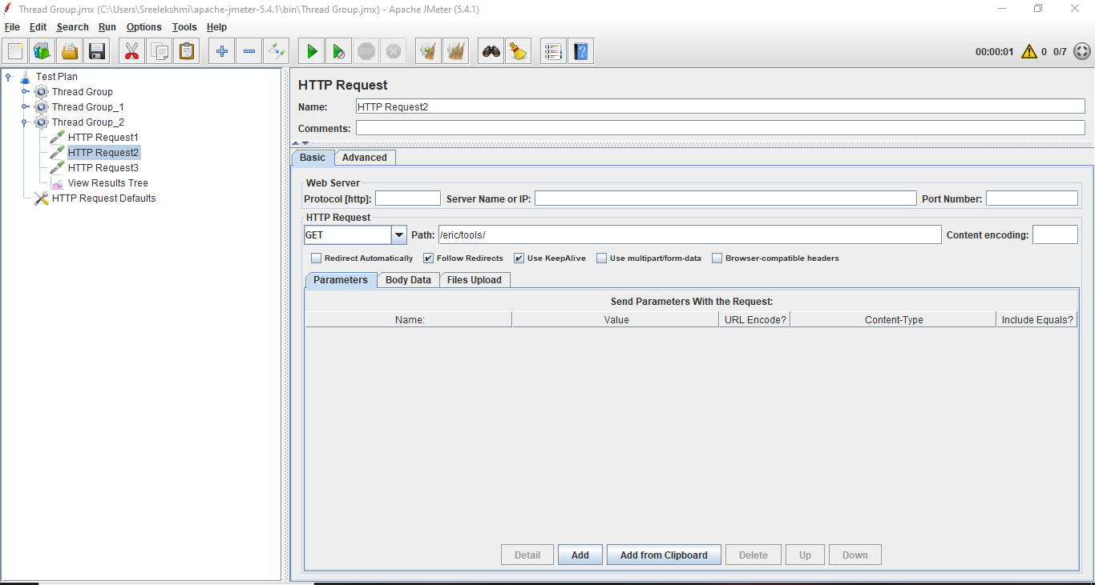After adding Second Sampler HTTP Request 2

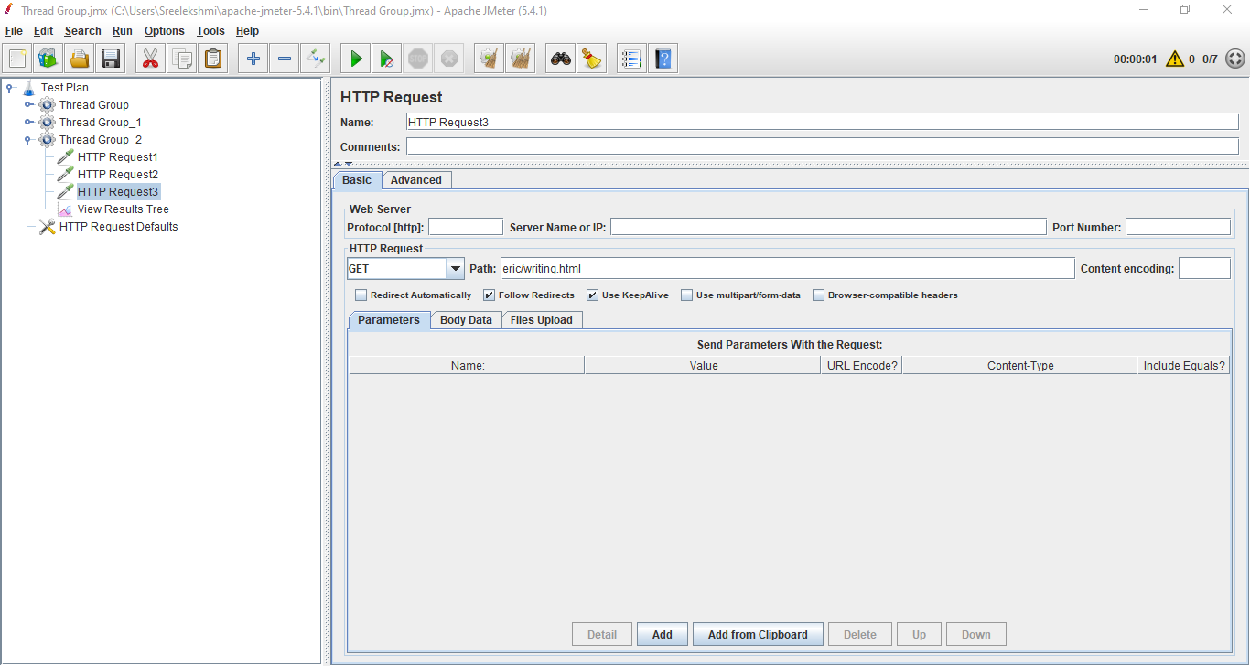After adding Third Sampler HTTP Request 3

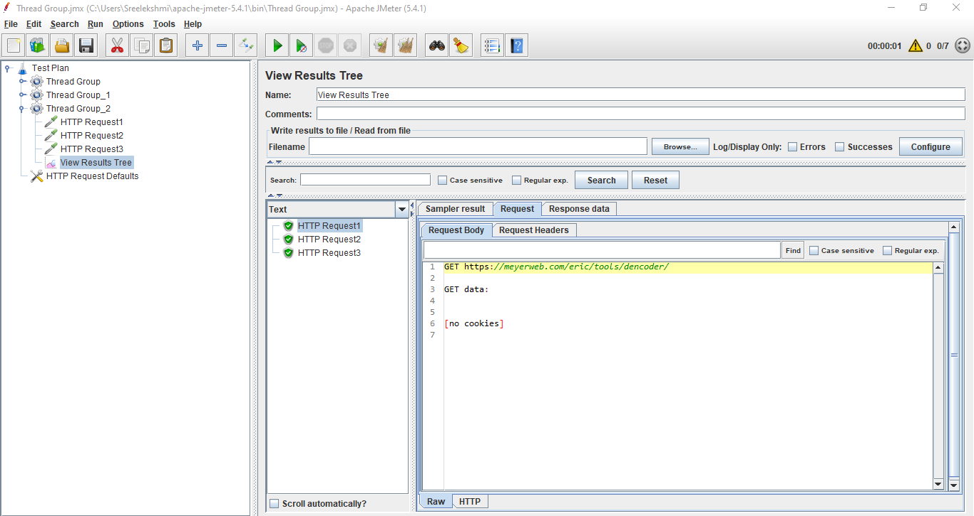Result of HTTP Request 1

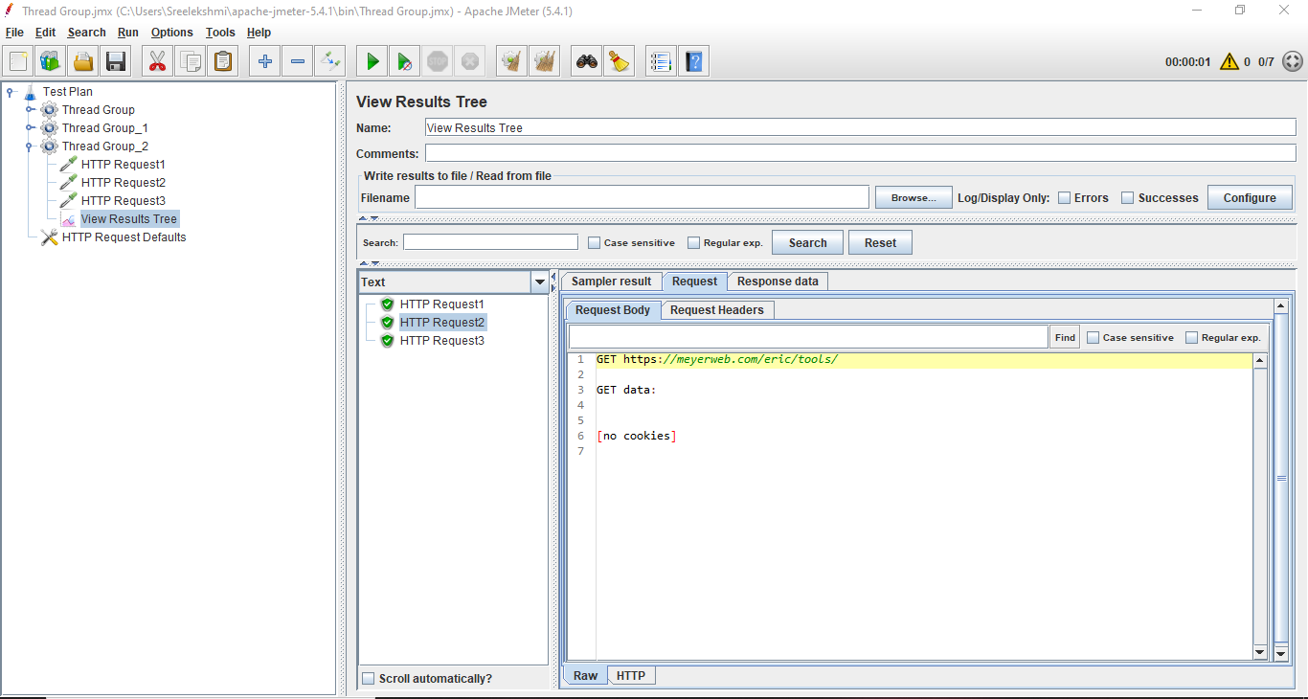Result of HTTP Request 2

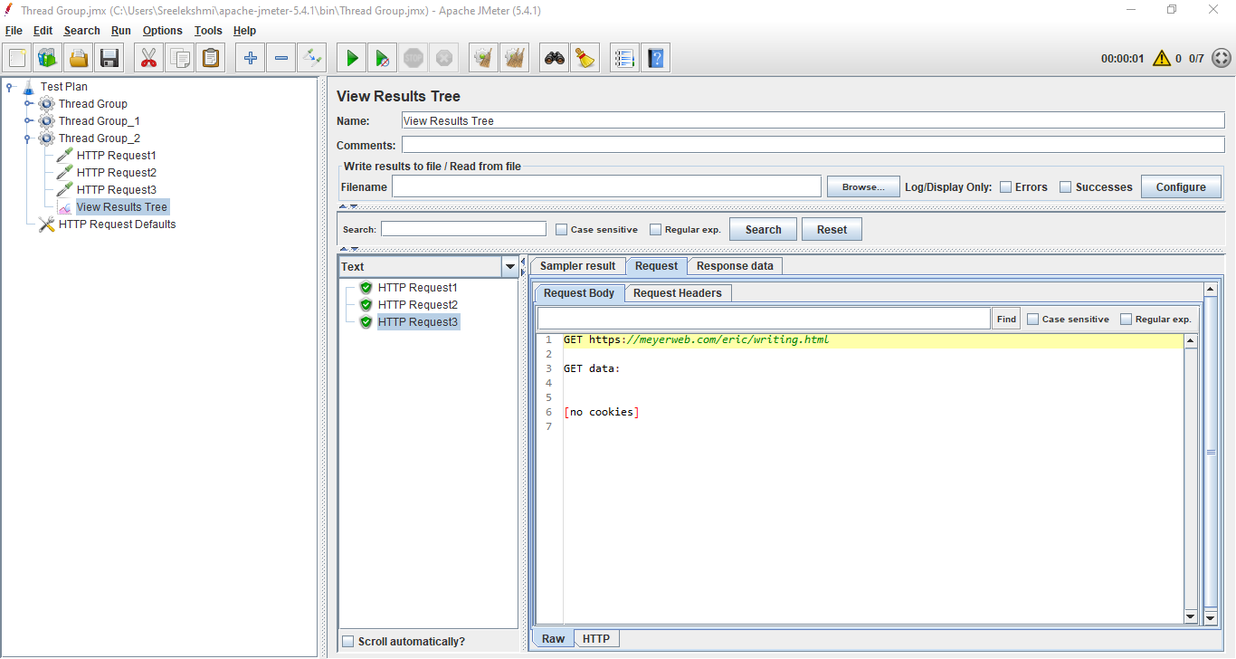Result of HTTP Request 3

**JMeter Example_4**

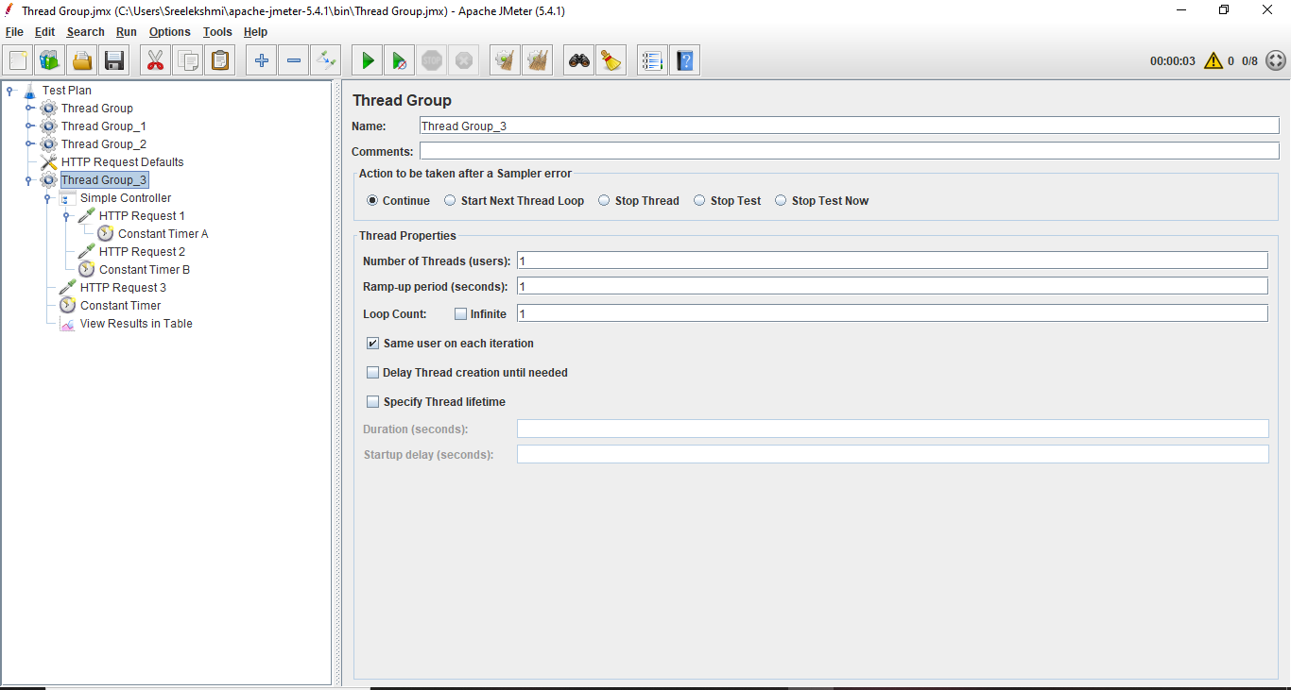After adding Thread Group

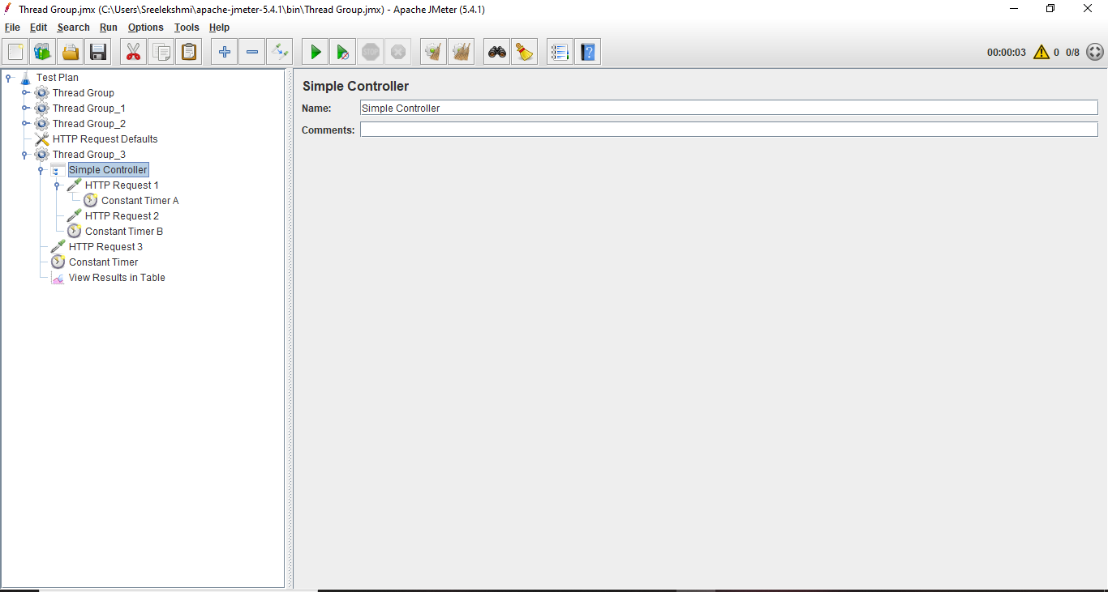**After adding the Logic Controller**

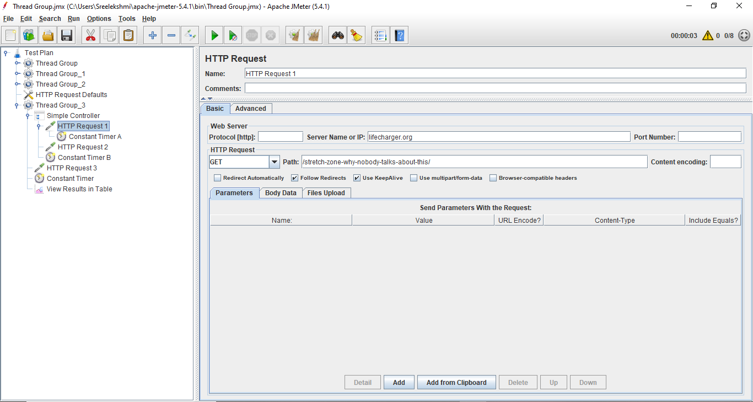After adding First Sampler HTTP Request 1

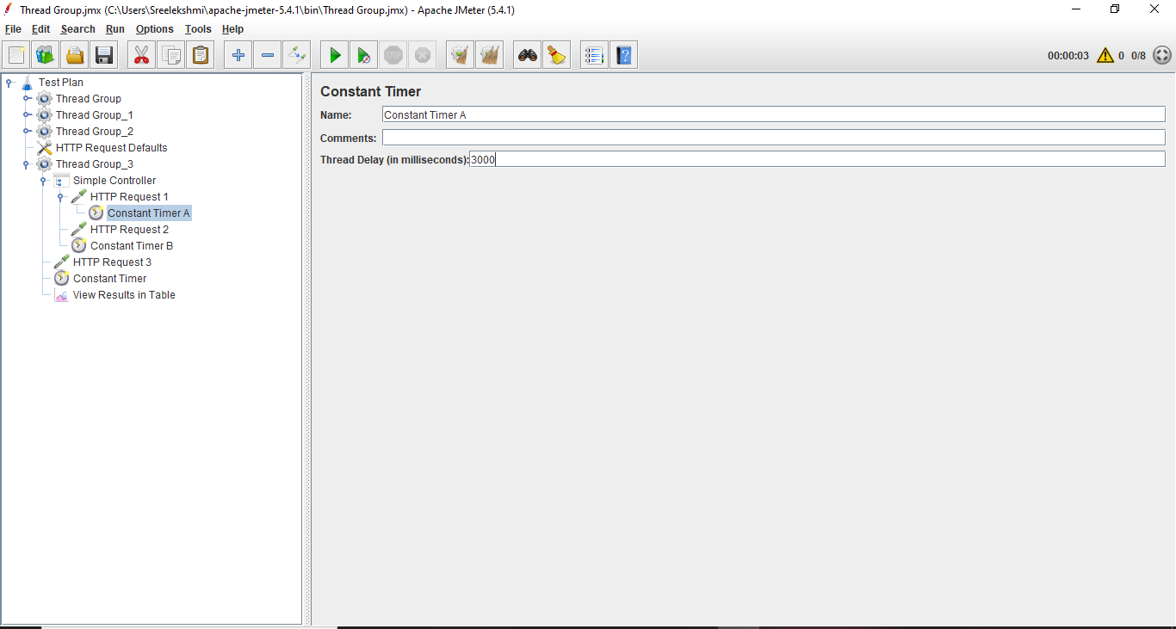First Constant Timer

After adding the 2nd Sampler HTTP Request 2

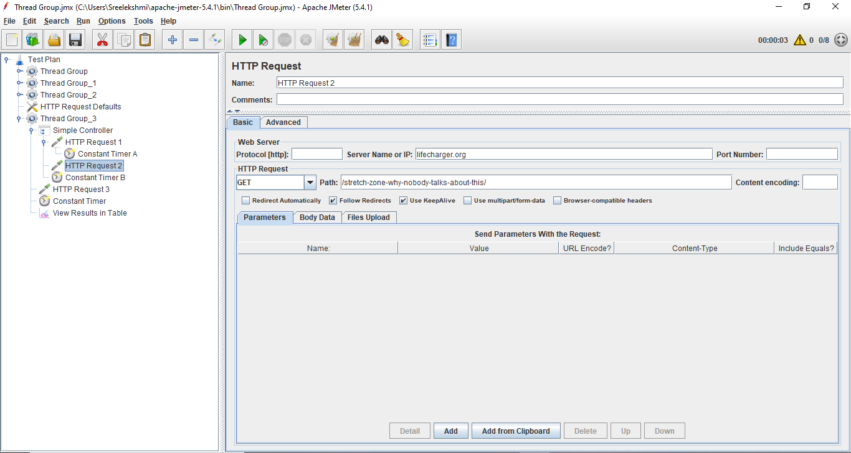

Second Constant Timer

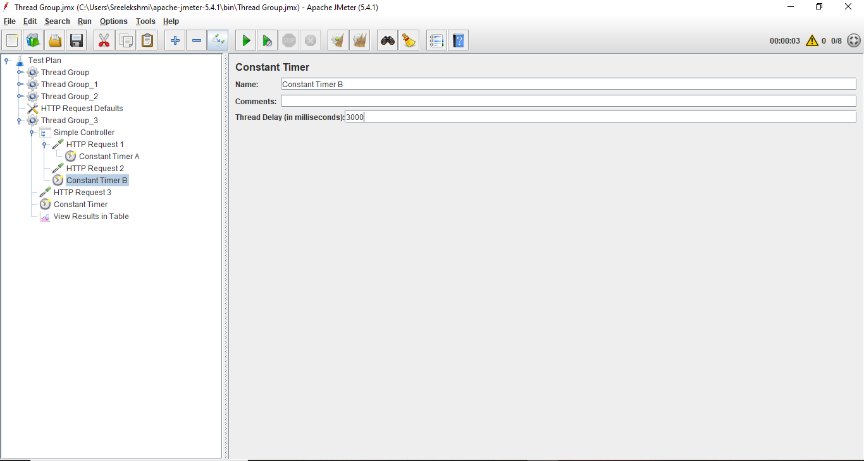

After adding the Third HTTP Request 3

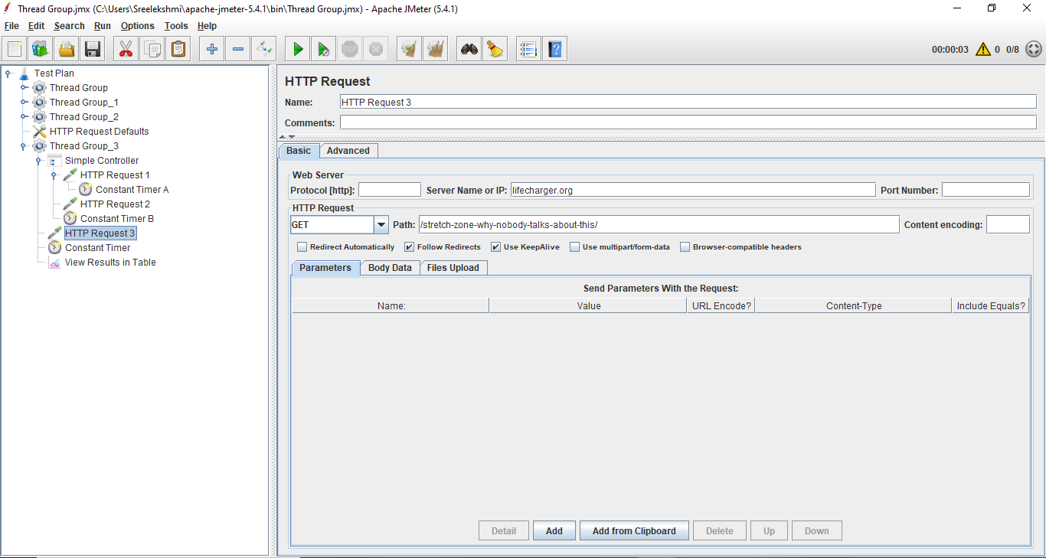

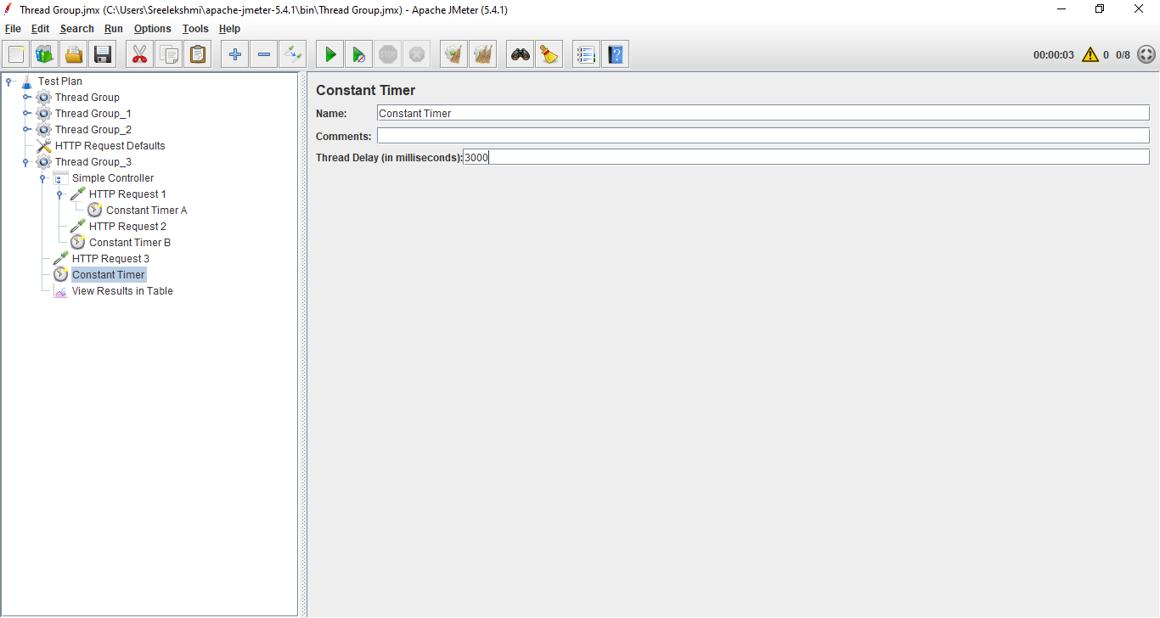Third Constant Timer

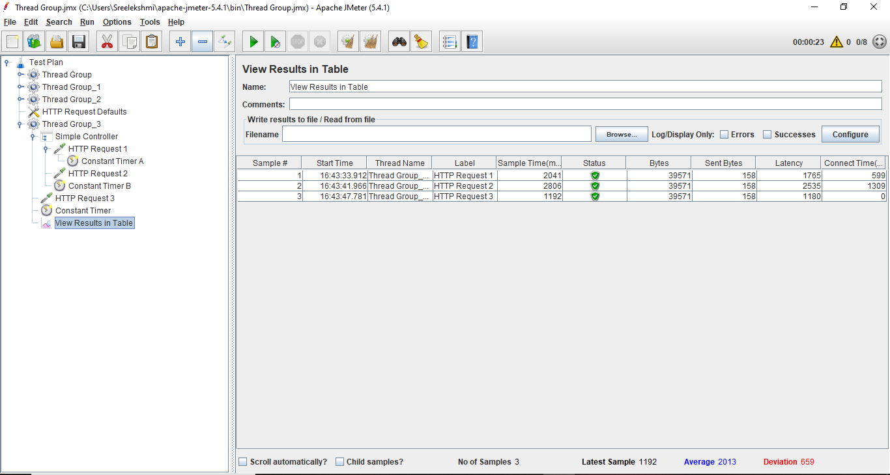Result of the HTTP Request in the Table format

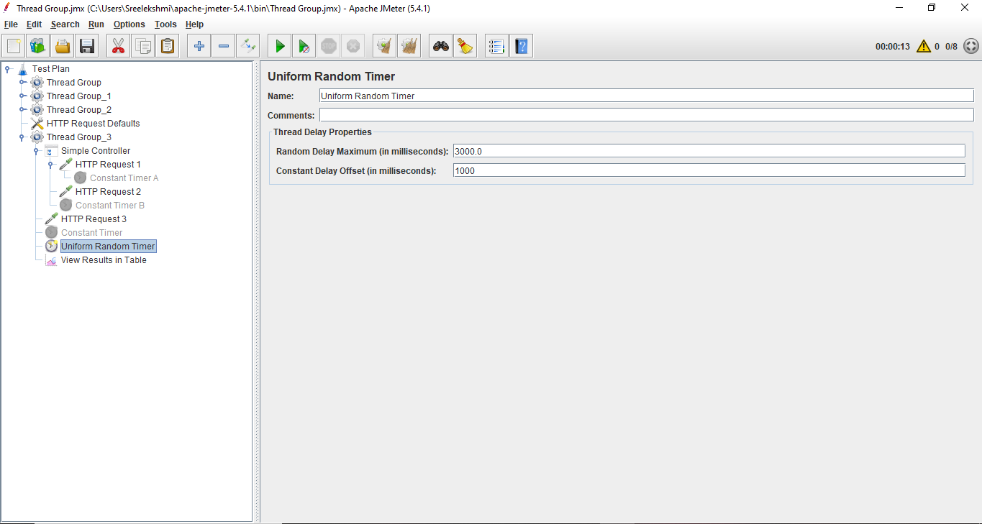After disable all the Constant Timer and added the Uniform Random Timer

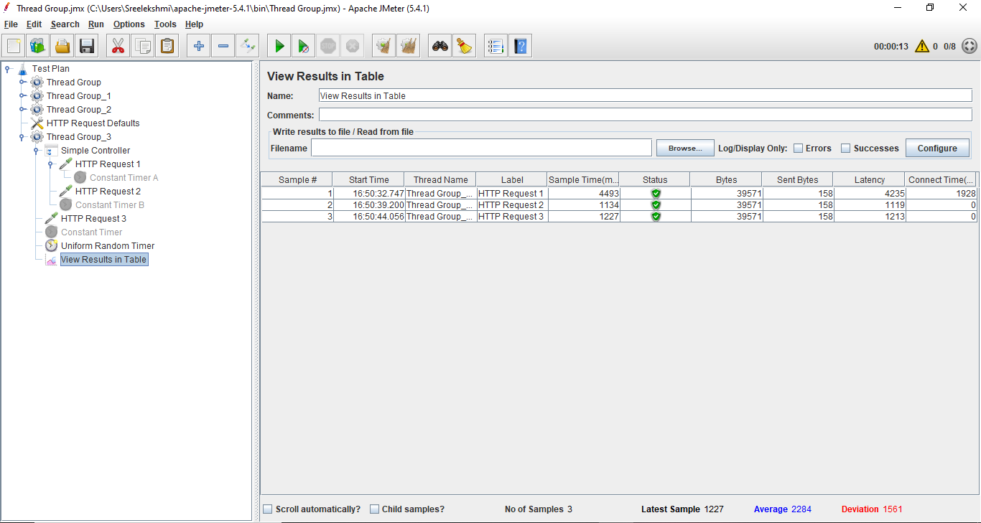Result After adding Uniform Random Timer

**Logic Controllers in JMeter**

Logic controller helps us define the order of request which need to be executed in the JMeter.

Steps:

* Create a new Test plan.
* Add new Thread Group.
* Add Two HTTP Request.
* Add a Listener.
* Change the loop number of tread to execute as 2
* Run the test

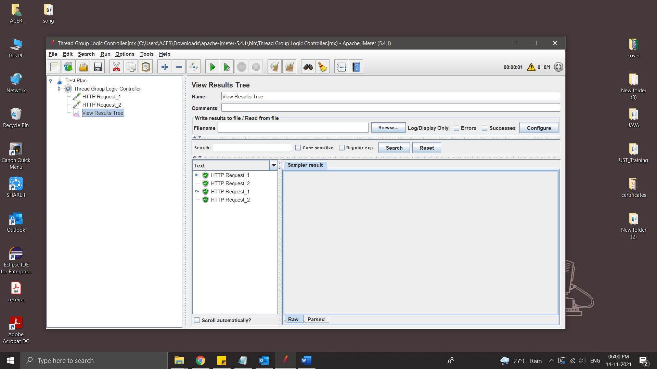

* Add Logic Controller – Simple Controller

Simple Controller doesn’t provide any functionality its just a container that contains user request.

Simple controller group the Thread request

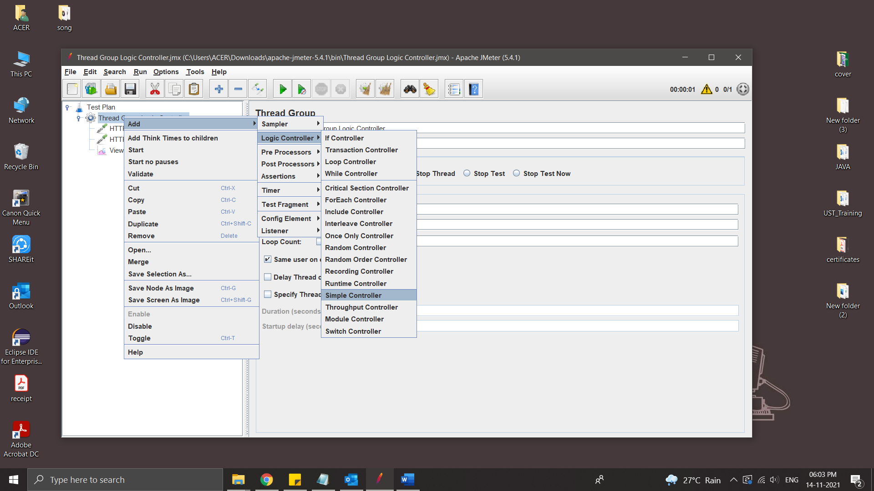

* Add some Thread Request inside the Simple controller and Run

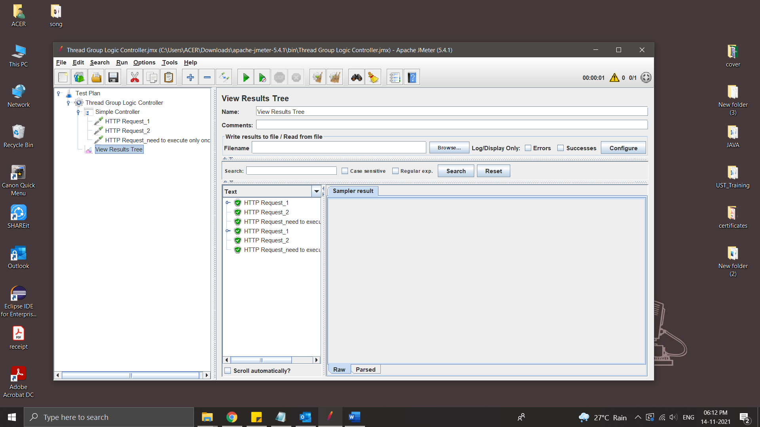

* Add Once Only Controller

Once Only Controller provides functionality to run any user request to run only once per loop. Add once only controller to thread group by using below steps.

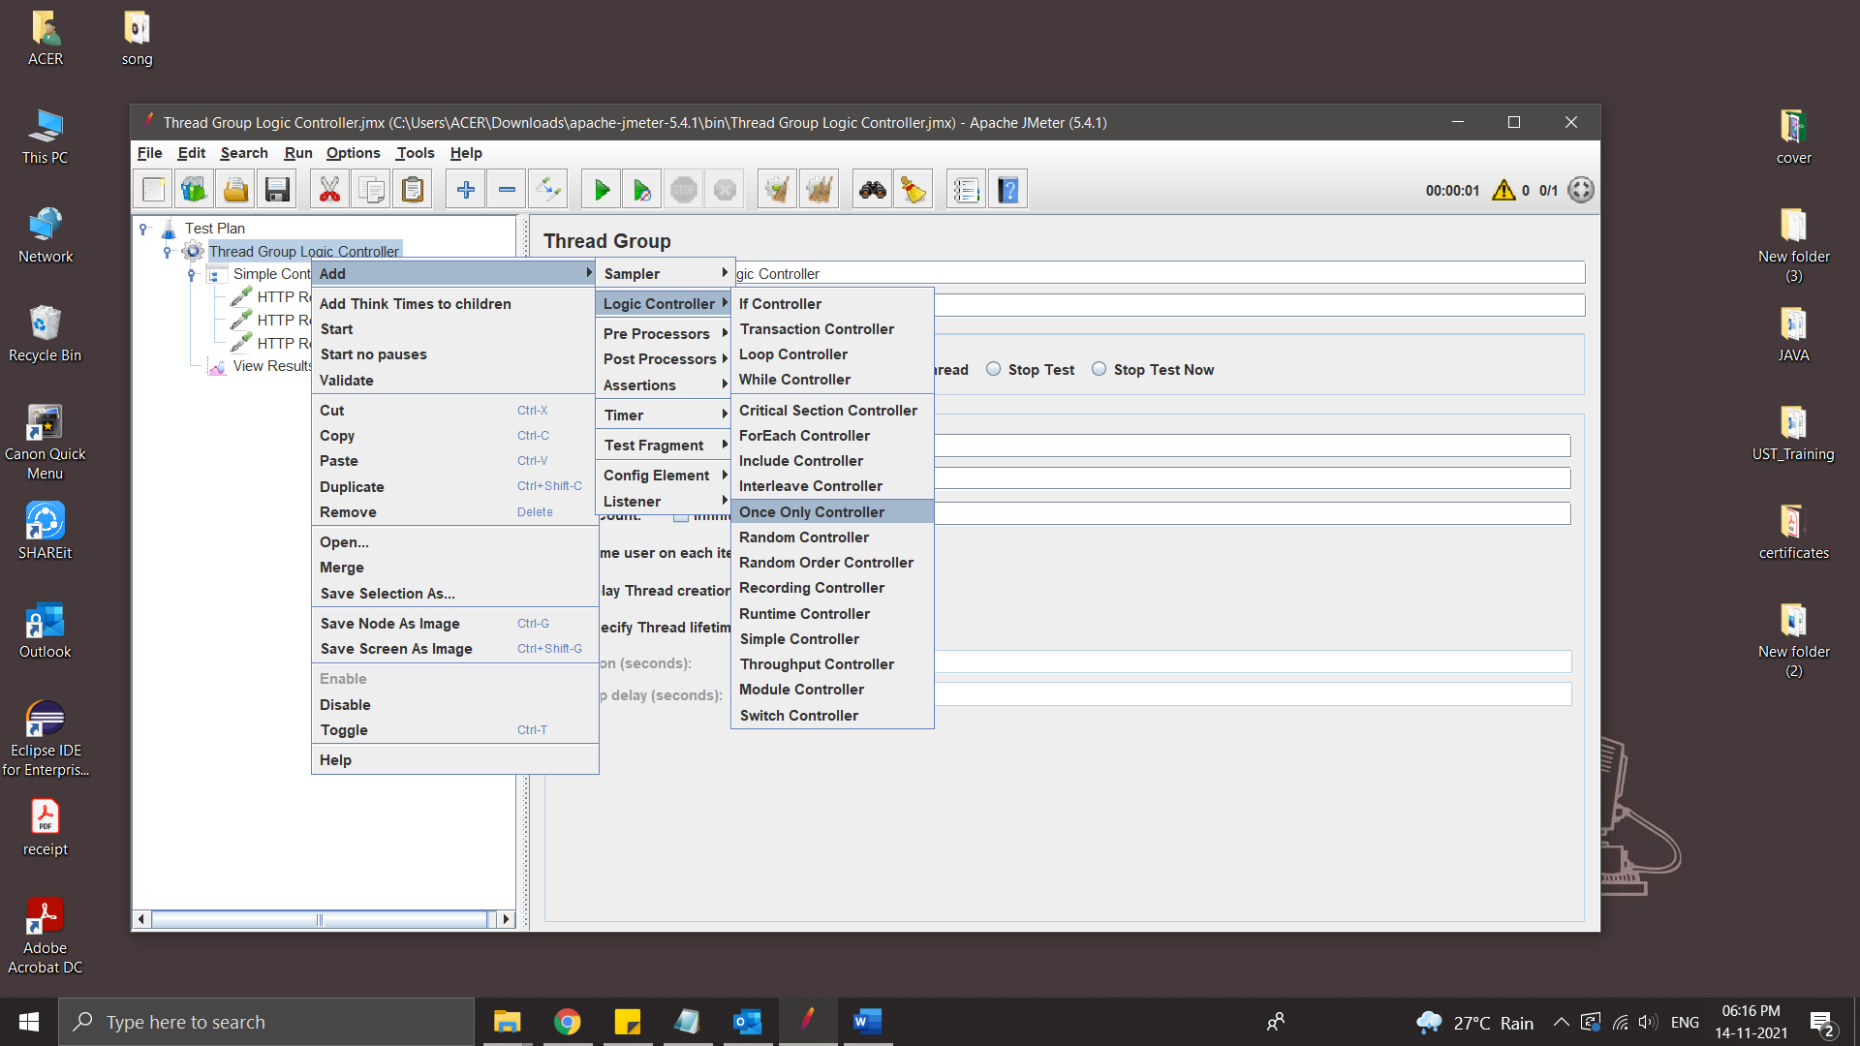

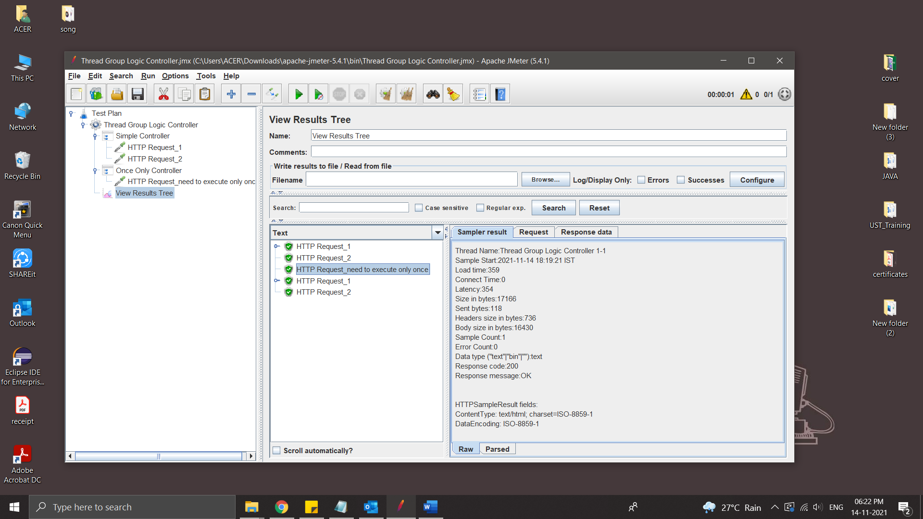

‘HTTP Request_need to execute only once’ is executed only once because it is inside the Once Only Controller

Module Controller

Module Controller provides functionality to run which module needs to run. Add module controller to thread group by using below steps.

Right click on Thread Group >> Add >> Logic Controller >> Module Controller

Examle:-

Creating some Scenario:

1.login and search a product

2.login and order a product

3.login and cancel order

Steps:

* Create a new Test Plan
* Create 3 Thread Group for 3 Scenario
* Create HTTP requestes
* Add a Listener

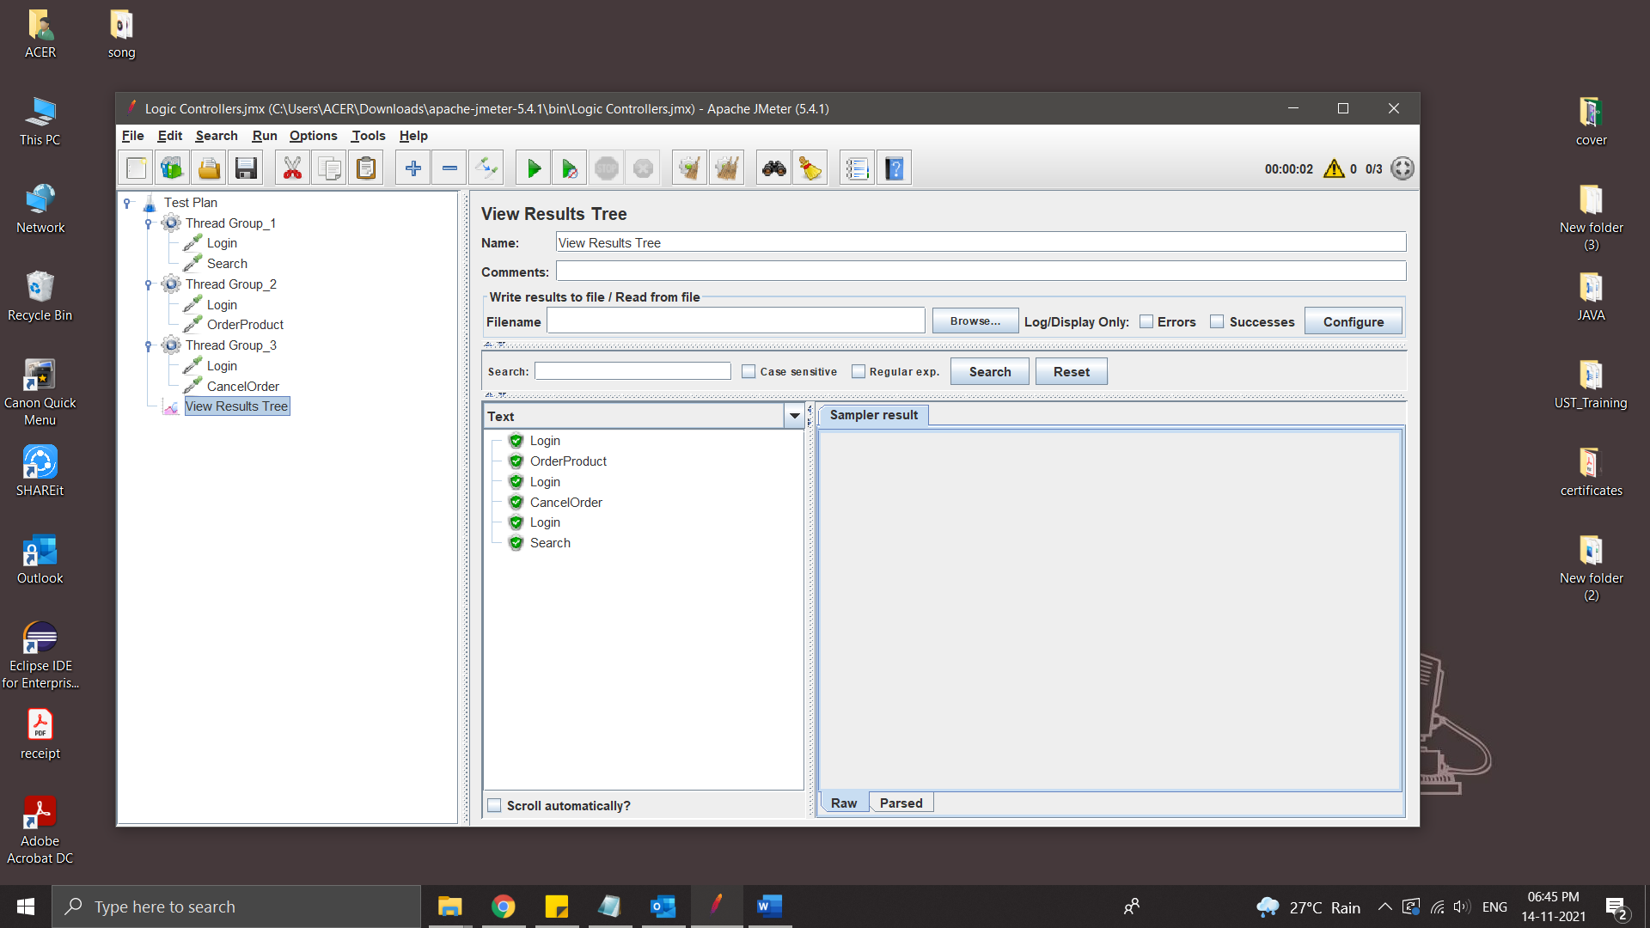

* Add Test Fragment

Test Fragment element is a special controller which can be added directly under JMeter test plan like Thread Group. But It does nothing except holding other elements inside!! It gets executed only when it is referenced by a Module/Include controller from other Thread Groups.

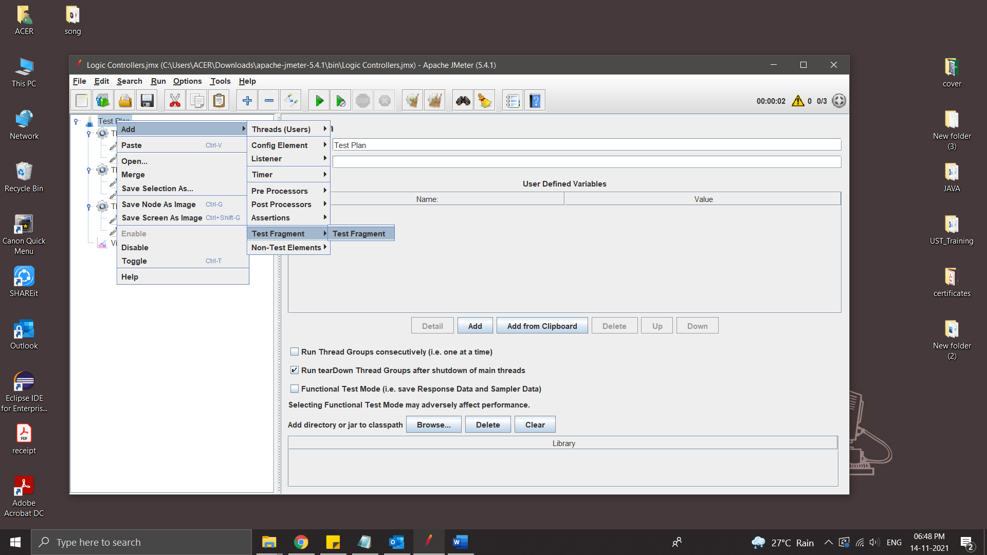

Place the request inside it [repeating Request is login]

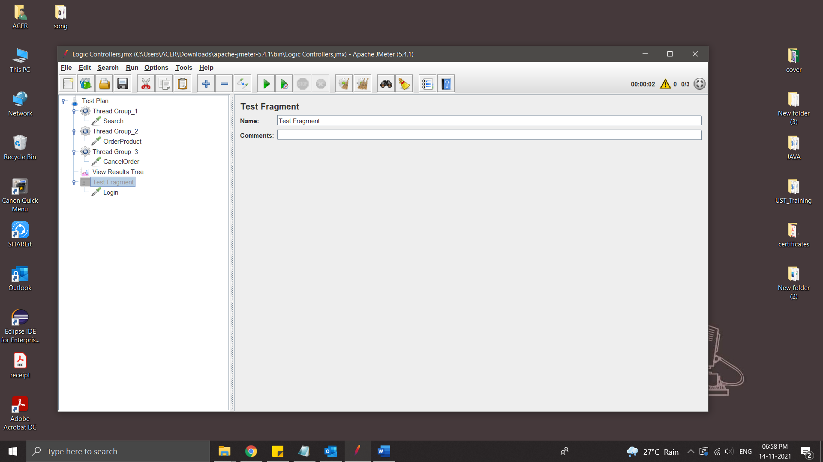

Request gets executed when called from controller like module controller/include controller

* Add Module controller

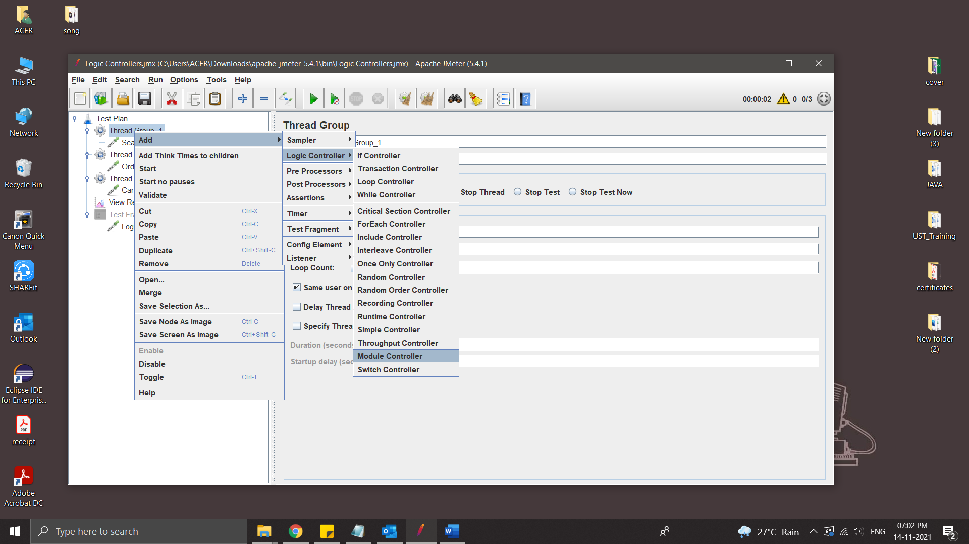

Select Test fragment

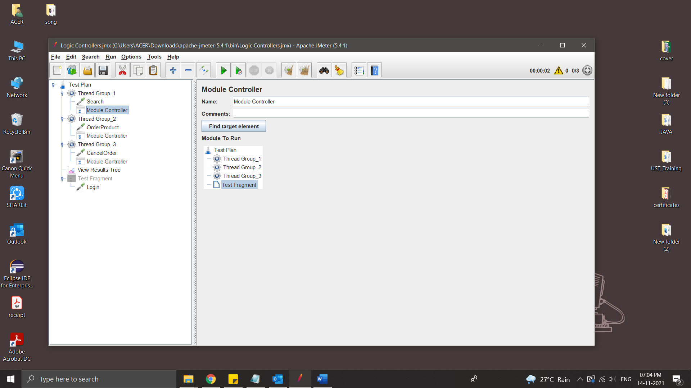

Add controller in all Thread group [because every thread group has login]

Run the Test plan [Same as previous Tread]

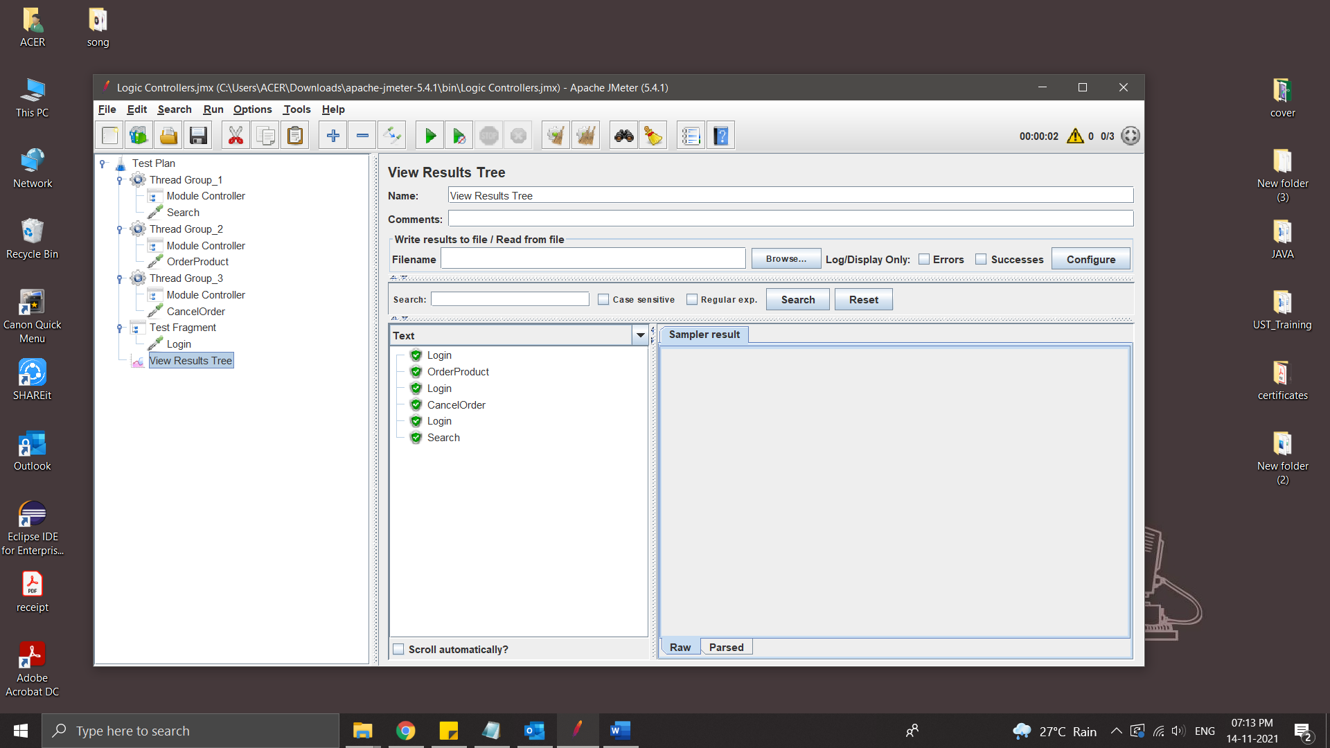

Include Controller

Include controller of JMeter is very useful if you want to break your test plan in small fragments. There are many different jmeter controllers available. Each of them has a different purpose as per its name.

Include controller is useful to include external test fragments in your test. Means you can include external test fragment in your software load test plan using include controller.

Include controller provides you the facility to use external test fragments in your test plan. So you have to save login steps as a test fragment and then you can use that test fragment in your all software load test plans using Include Controller

Example:

Scenario

1.Login

2.Search product

4.Cancel Product

Steps:

* Add Thread Group
* Save login as JMX file for include controller

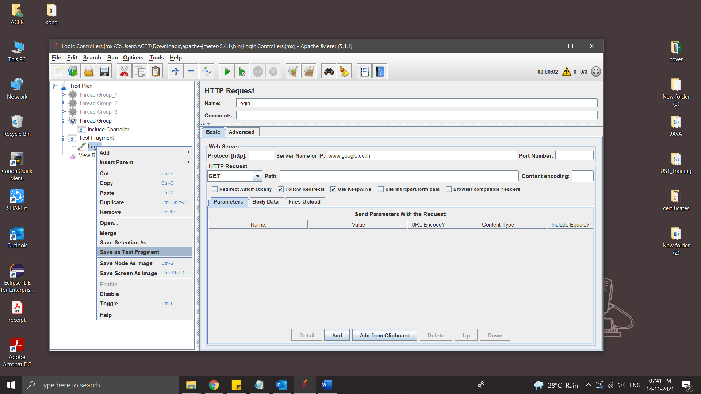

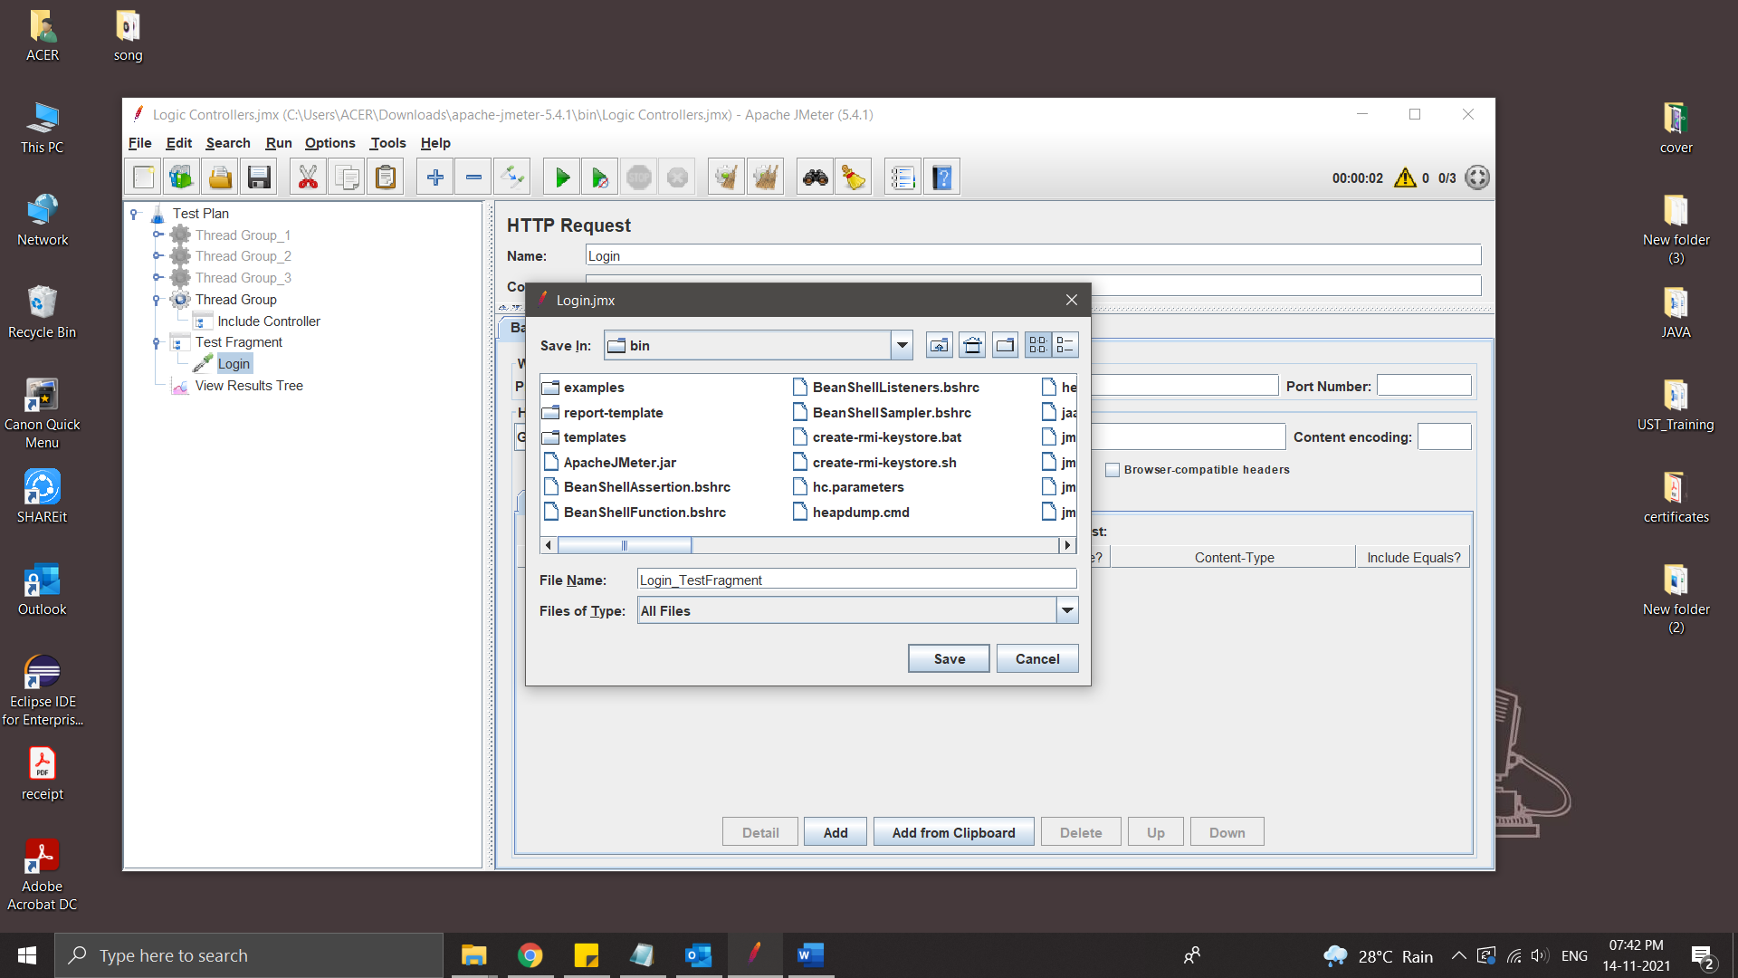

* Add include controller inside Thread group

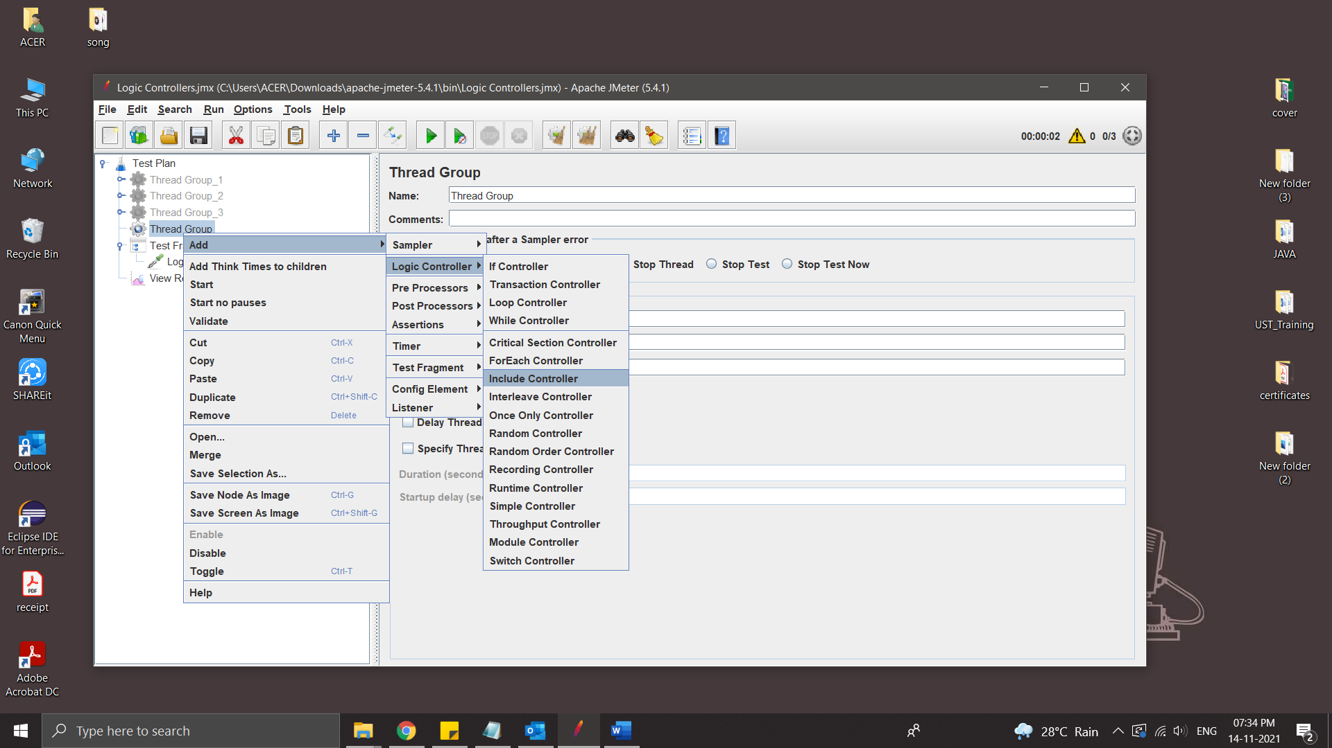

* Add File

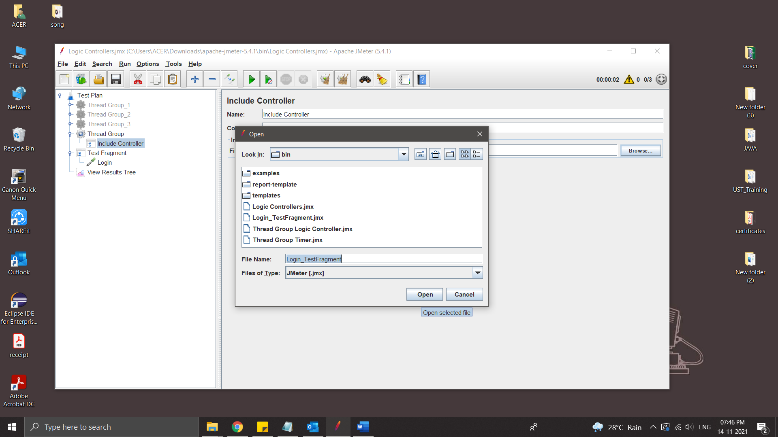

* Add requests inside the Thread Group and Run

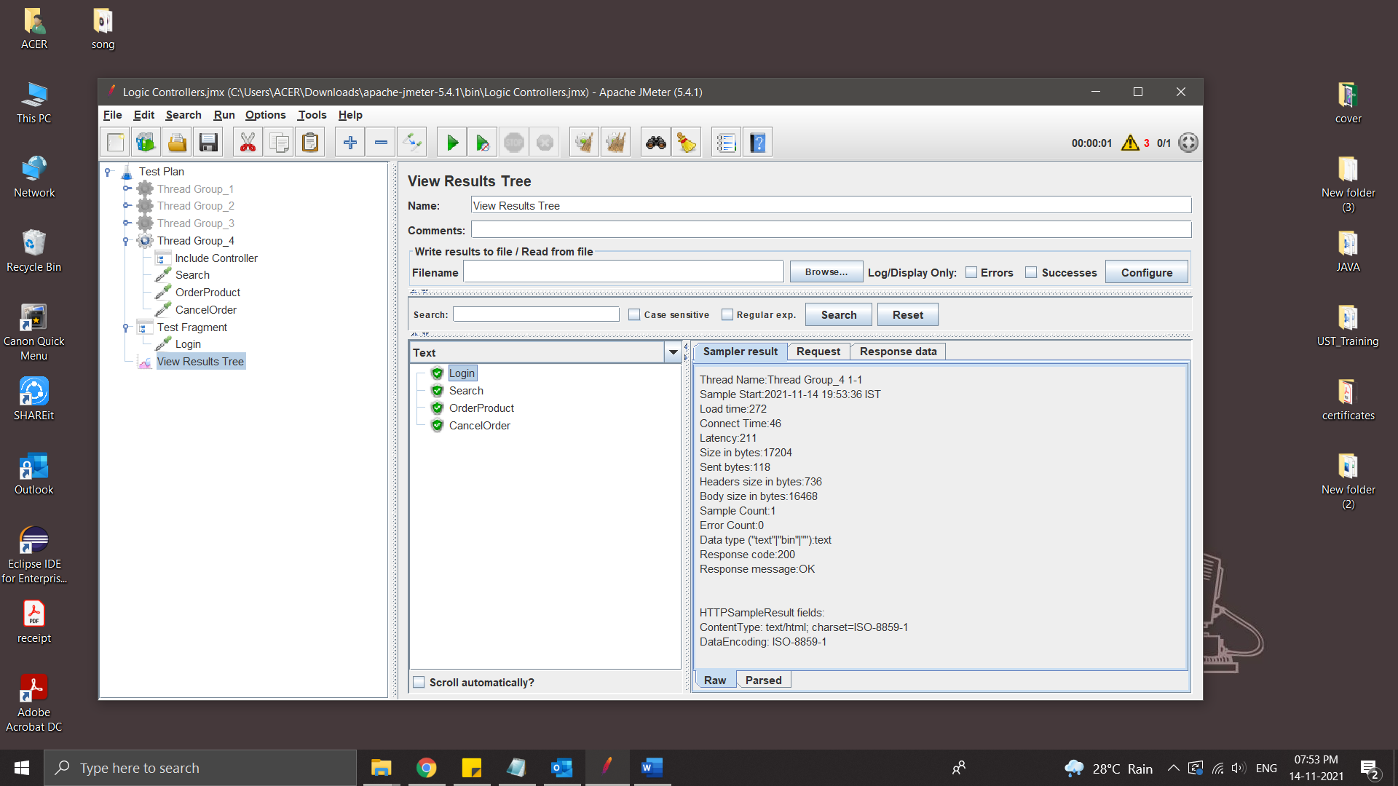

**JMeter Pre & Post Processors**

Pre Processor executes before the sampler execution. Post Processors are used to execute the response data from the server and to save the specific extracted values for later use.

User parameter

The User Parameters PreProcessor specifies user input parameters specific to individual threads. For each thread, the variable value will be used based on the order of that user thread in sequence.

Steps:

* Create a Thread group
* Add pre processor – User Parameters

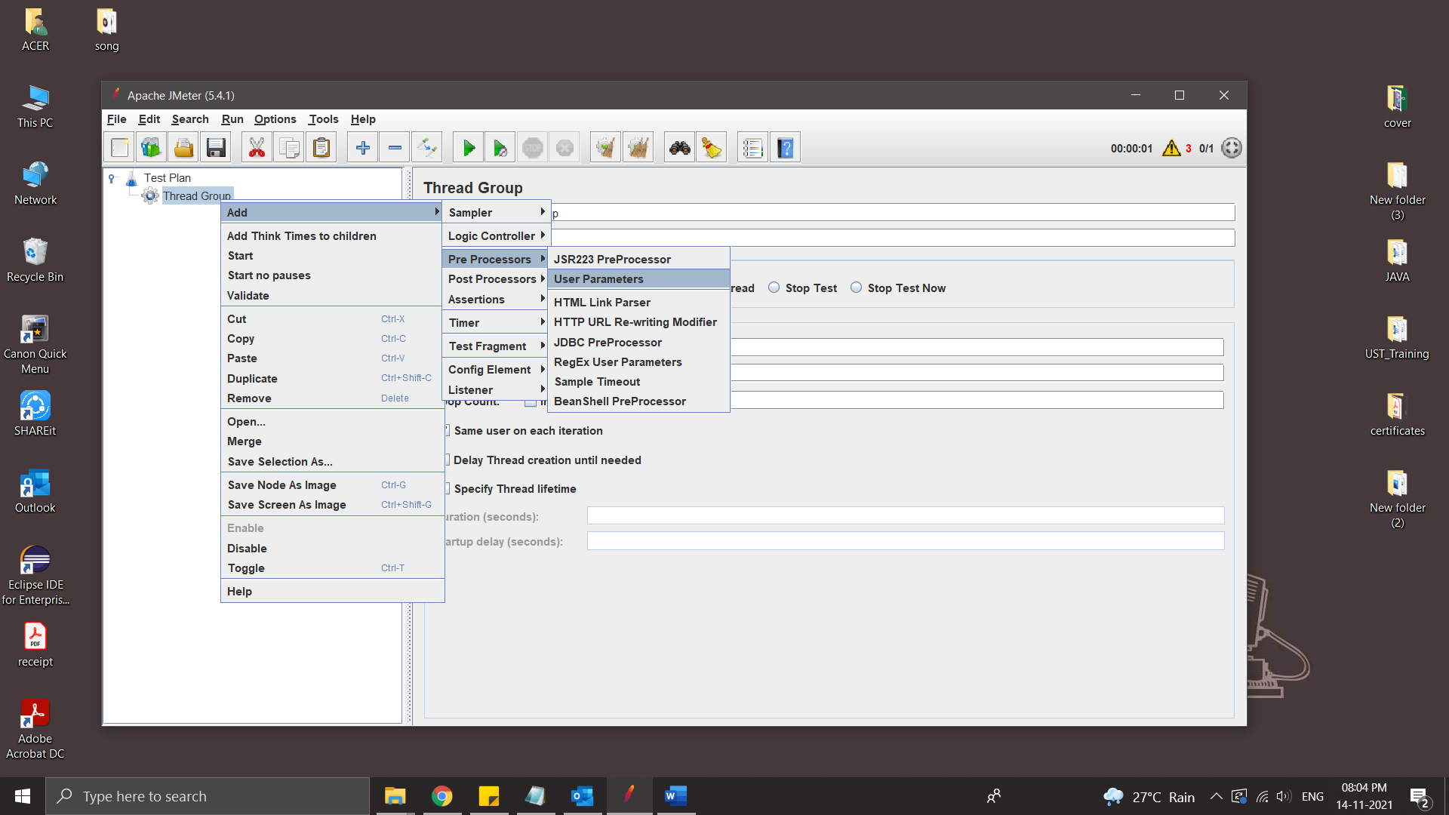

* Add name and users in User parameter

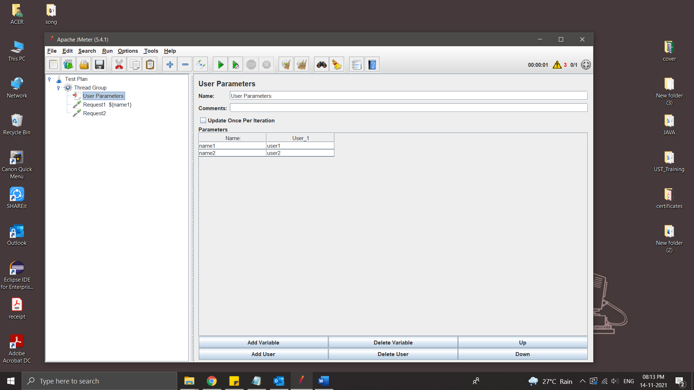

* Add Request

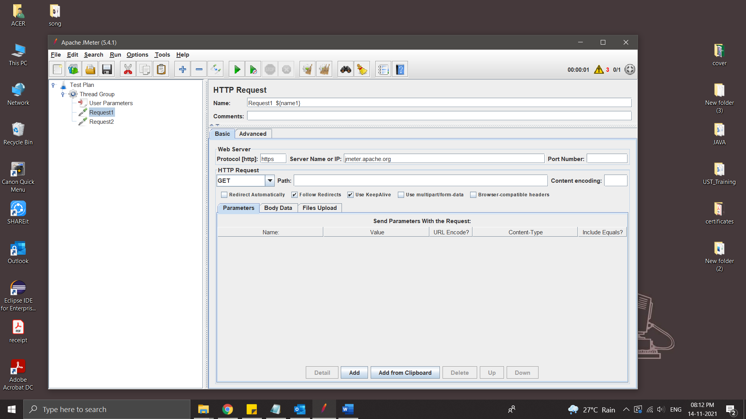

* Run

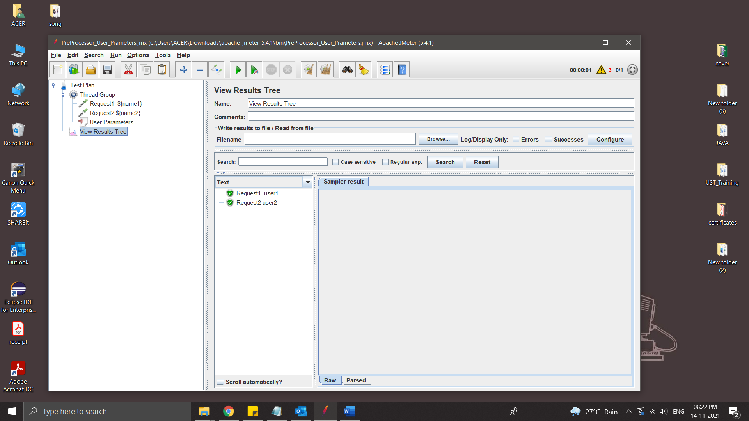

HTML Link Parser

The HTML Link Parser PreProcessor can be used to parse a response, extract all the found links and request them further. This can be useful when the main goal of your script is to simulate web crawling.

Steps:

* Create a Thread Group
* Add a HTTP Request
* Add another HTTP Request and add HTML Link Parser inside the request

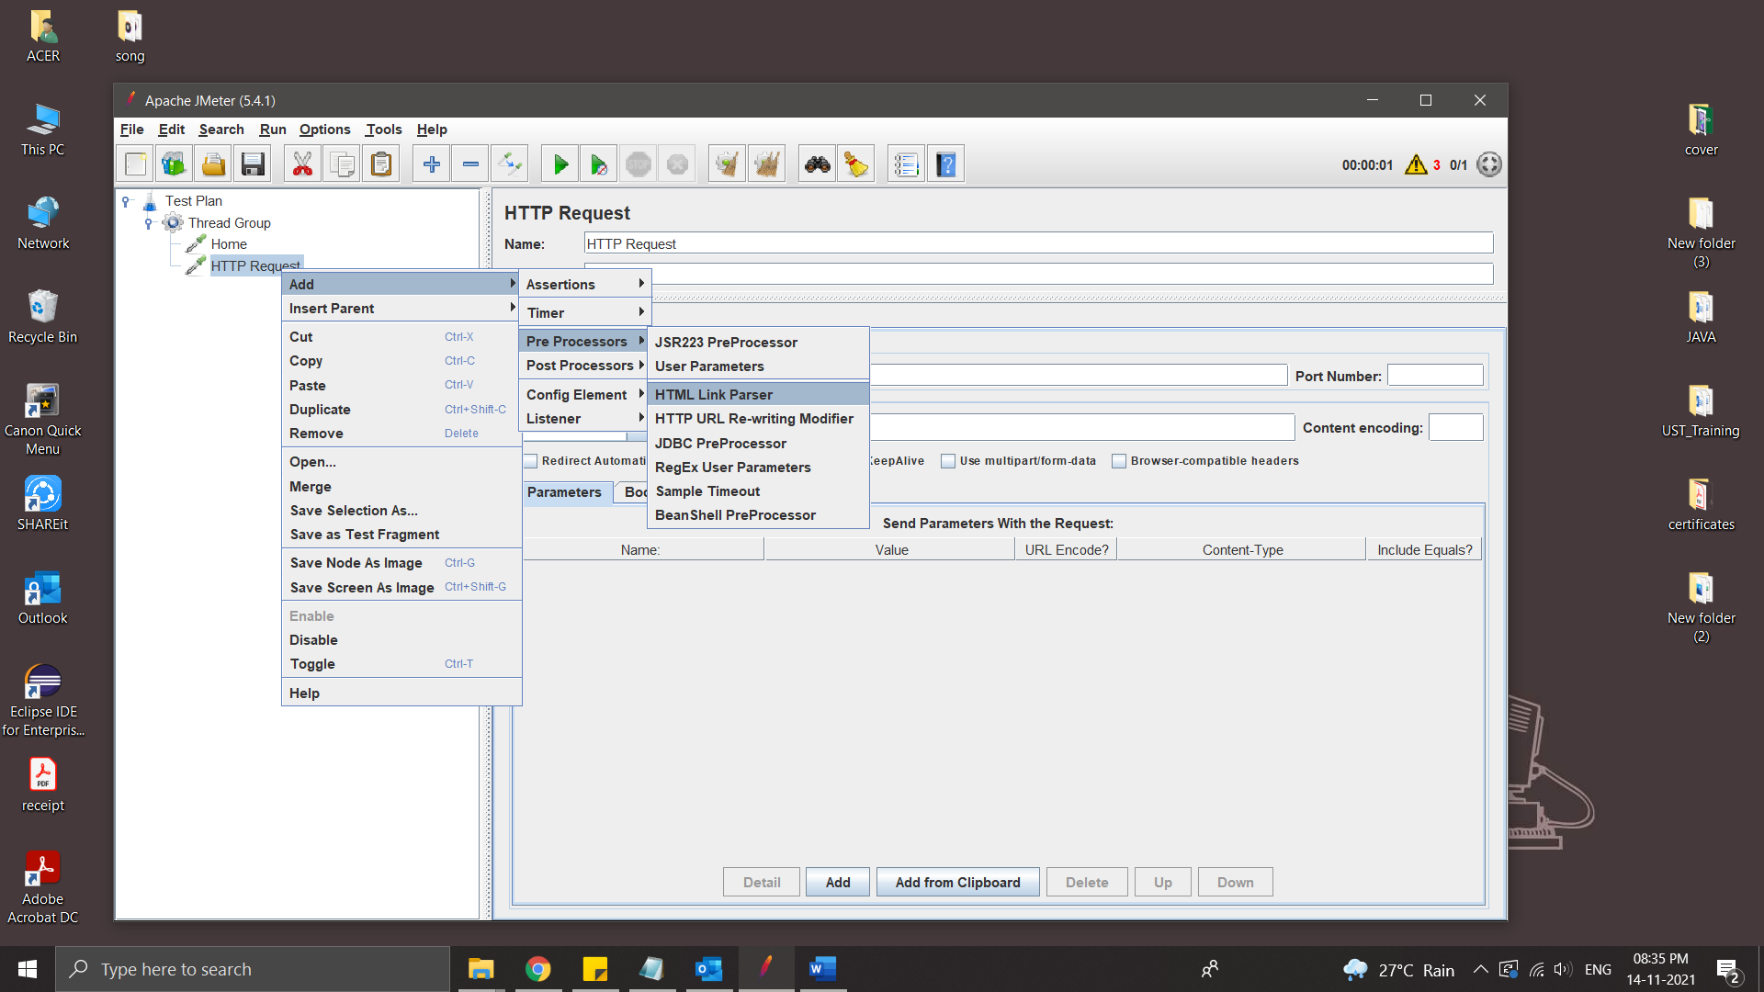

* .* take all the links in that html page

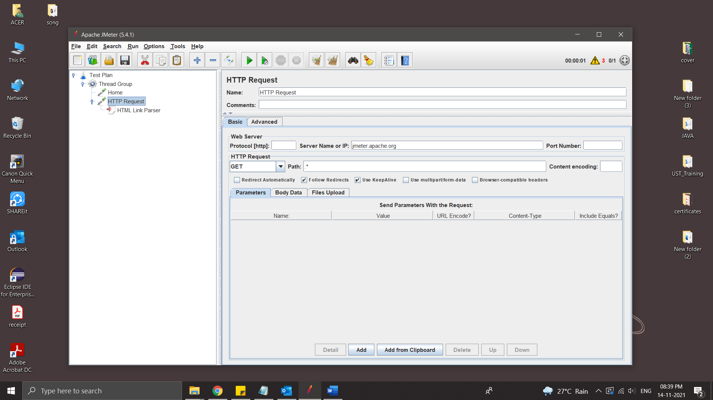

* Run

Http Resquest take a random link to test

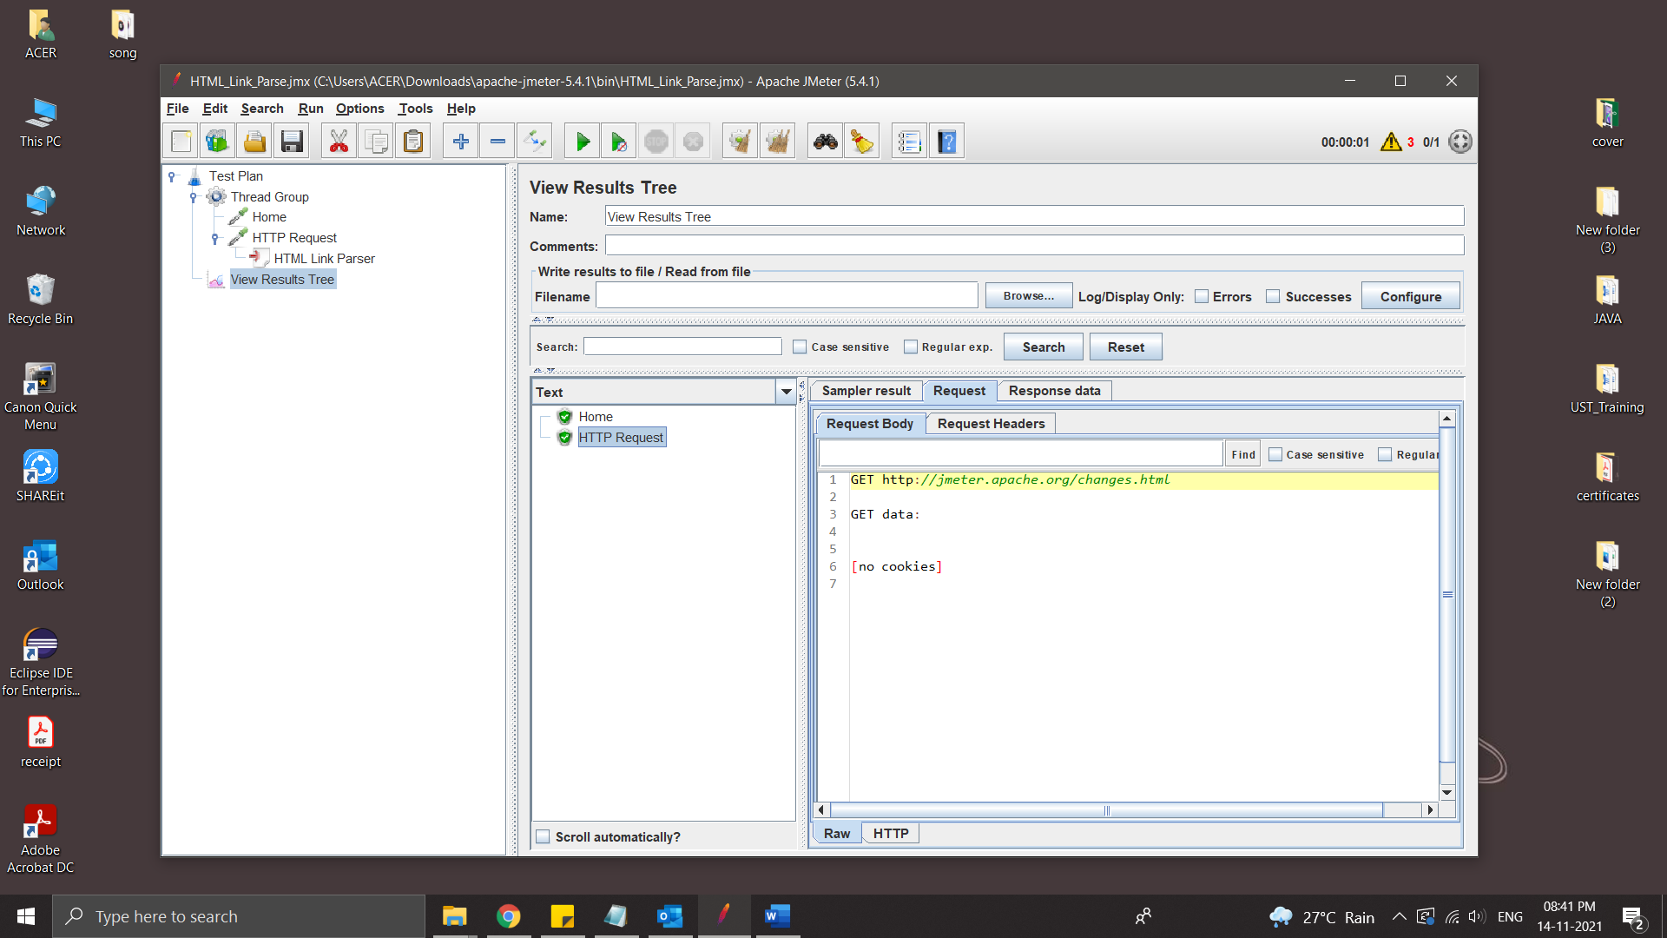

* If we wants to test all link the we place the HTTP request inside a While Controller

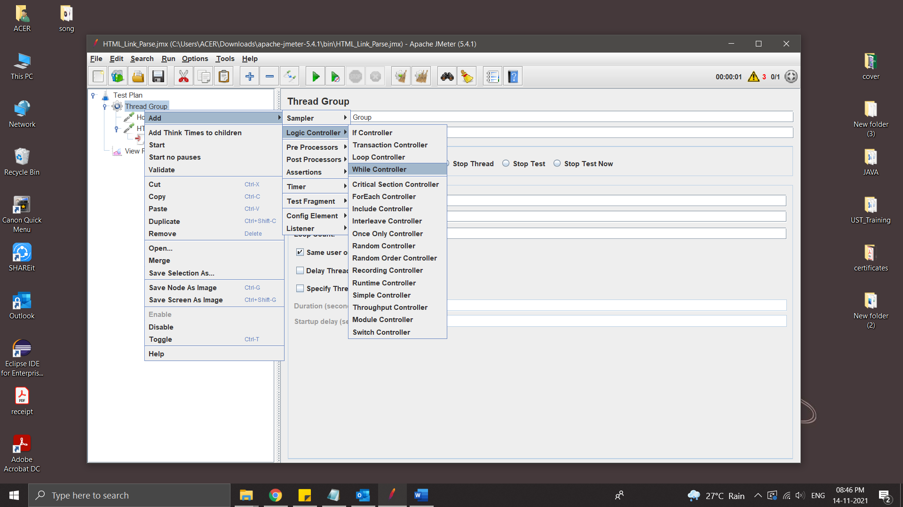

Run

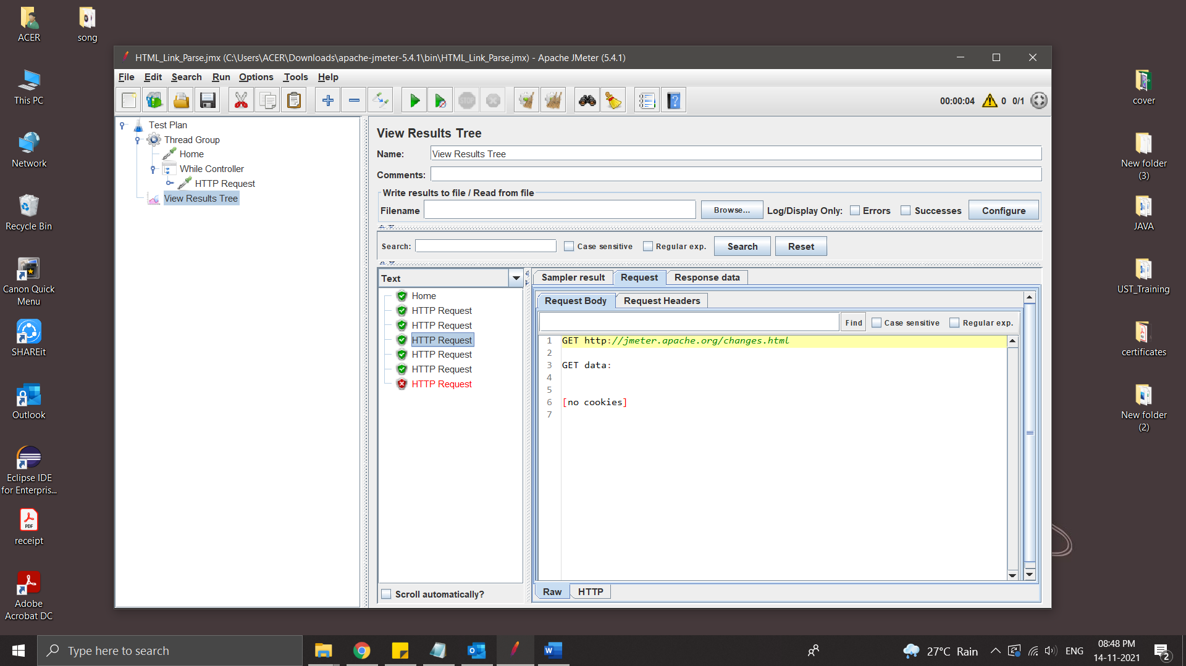

Post-Processors

Post-Processors are actions that are performed after your sampler has been executed. You can use them to perform some actions on your response or extract some values out from the response and save them in a variable that can be used later.

Result Status Action Handler:

Result Status Action handler let the user select the action to be taken when sampler gets any error.

Below actions can be taken:

* Continue
* Start next thread loop
* Stop thread
* Stop test
* Stop test now
* Break Current loop
* Go to the next iteration of the current loop

Steps:

* Create Thread Group
* Crete two Java Request
* Add Post Processor - Result Status Action Handler

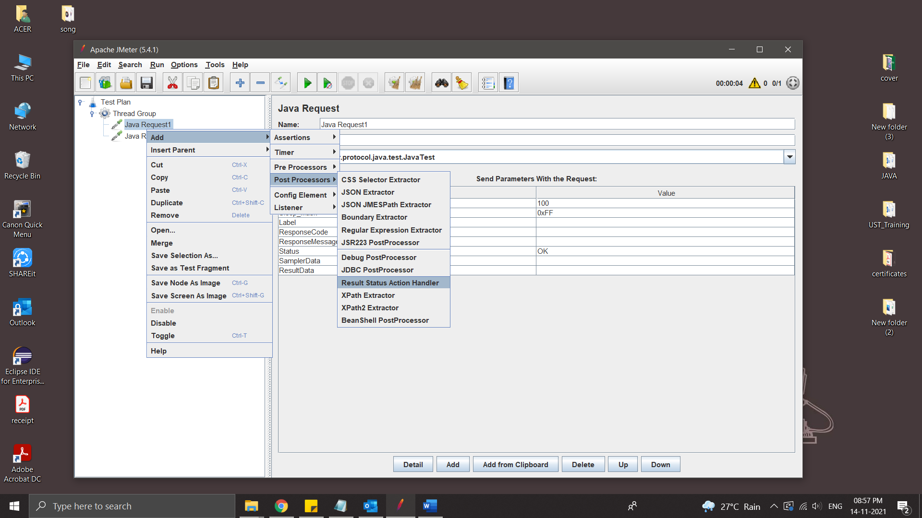

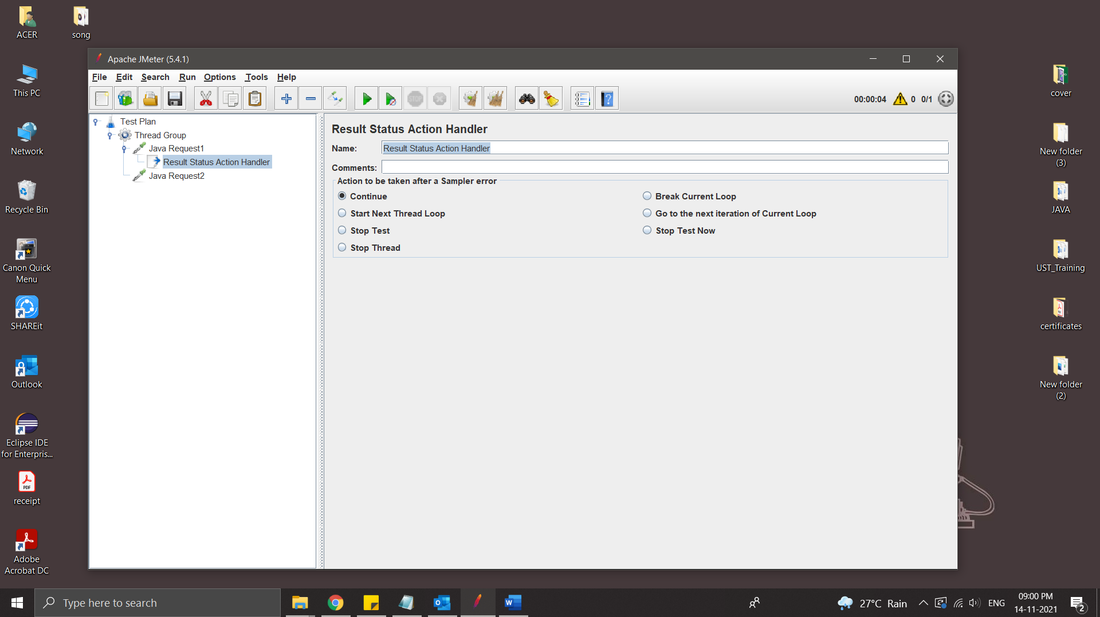

**JMeter Variables And Functions**

Function – methods used to populate fields in any other elements of a test plan

Syntax :

${__functionName}

${__functionName(var1,var2,…)}

Variables – Containers that can store values, which can be referred in any element within a thread.

Syntax :

${varName}

Steps:

* Create Thread Group
* Add Java Request

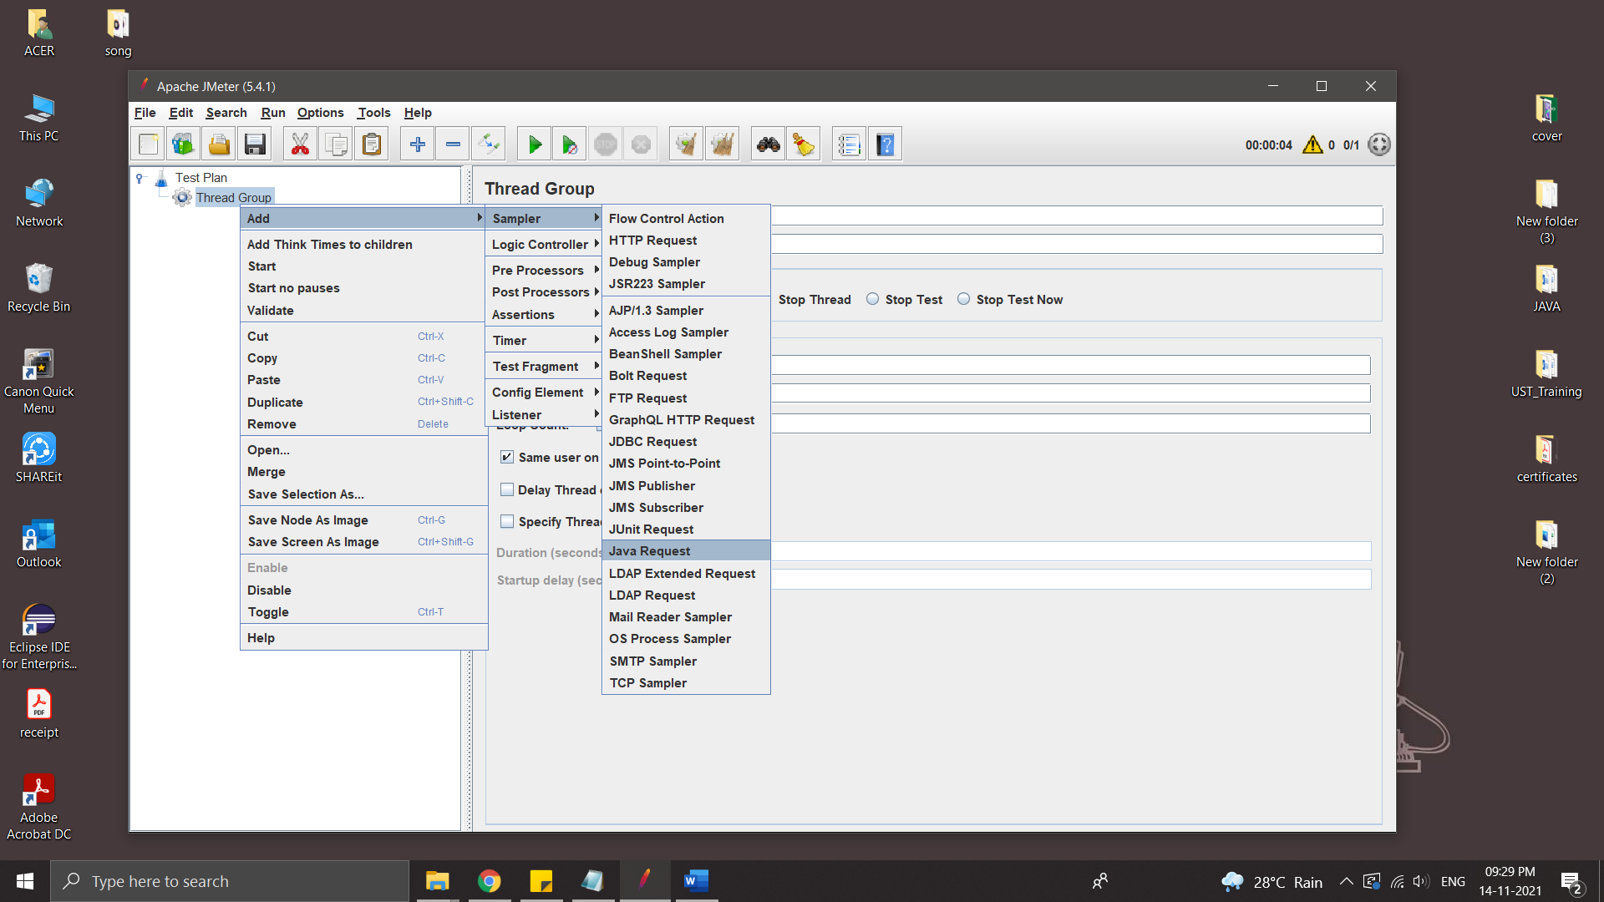

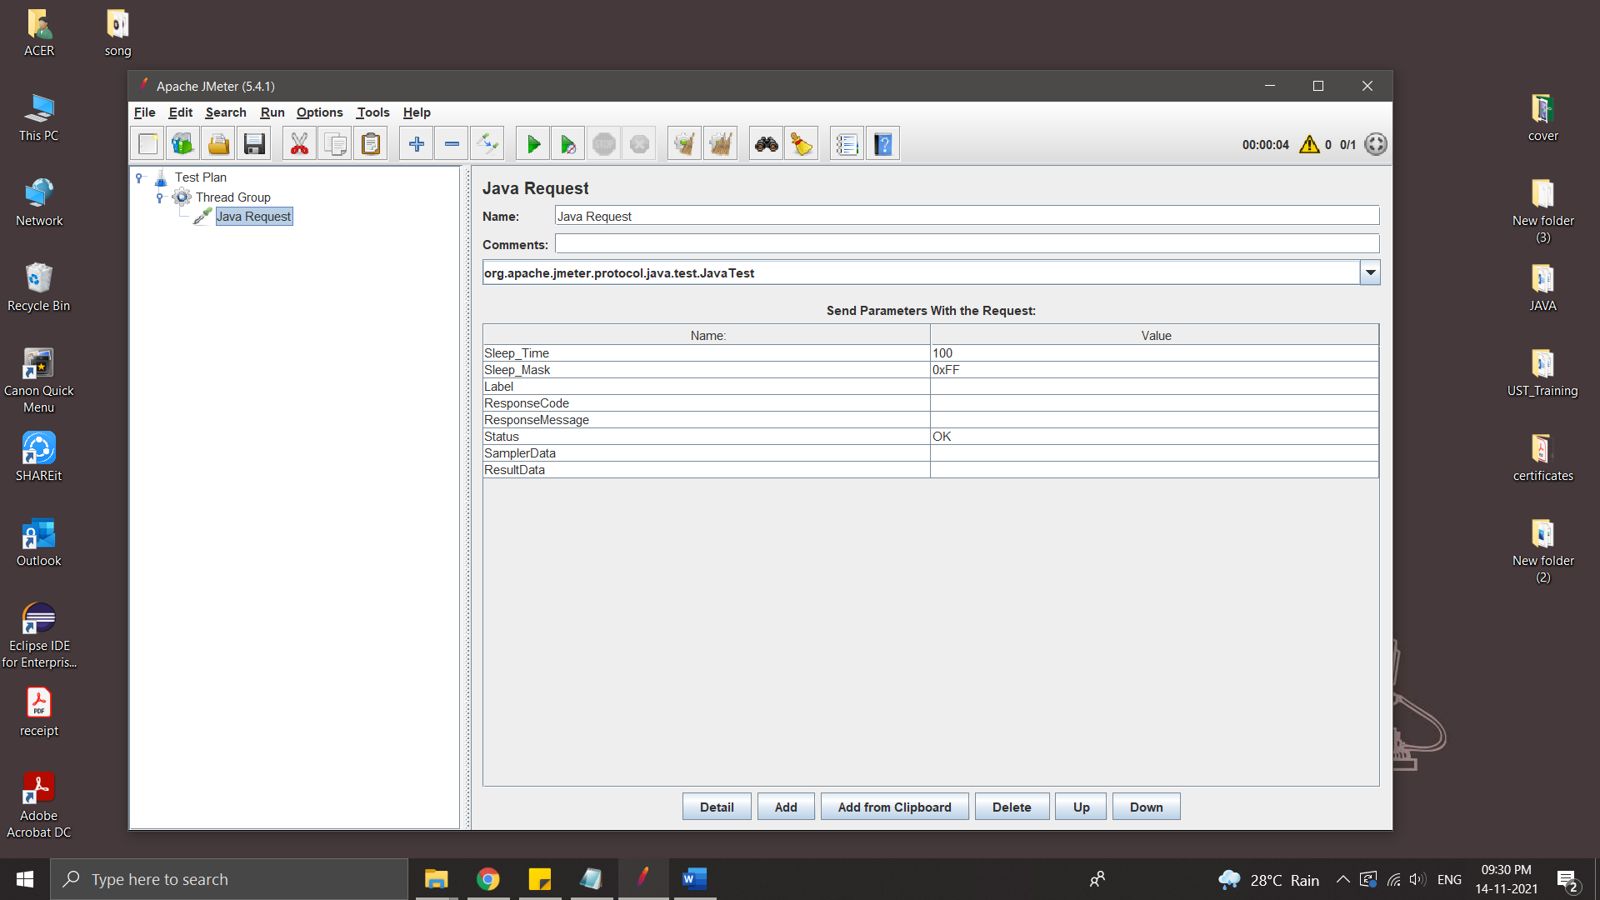

* help of Functon Helper Dailogue we can copy fuction code

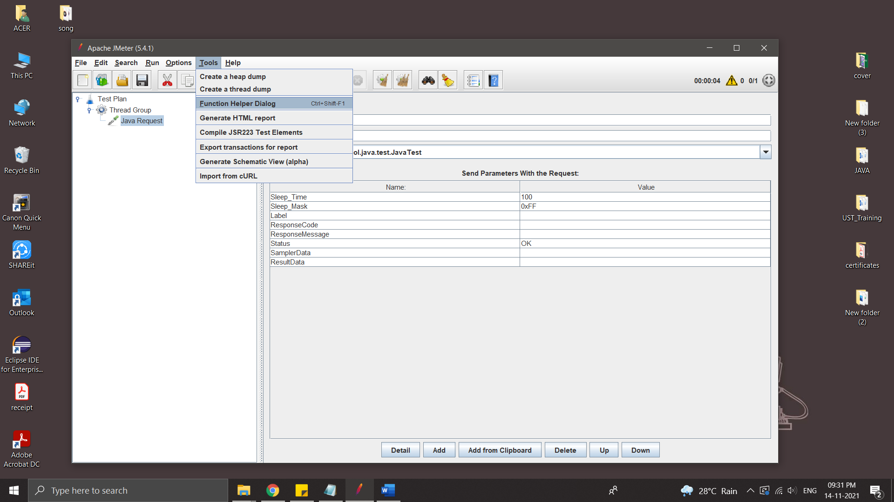

Select the fuction and click Generate & Copy to Clipboard

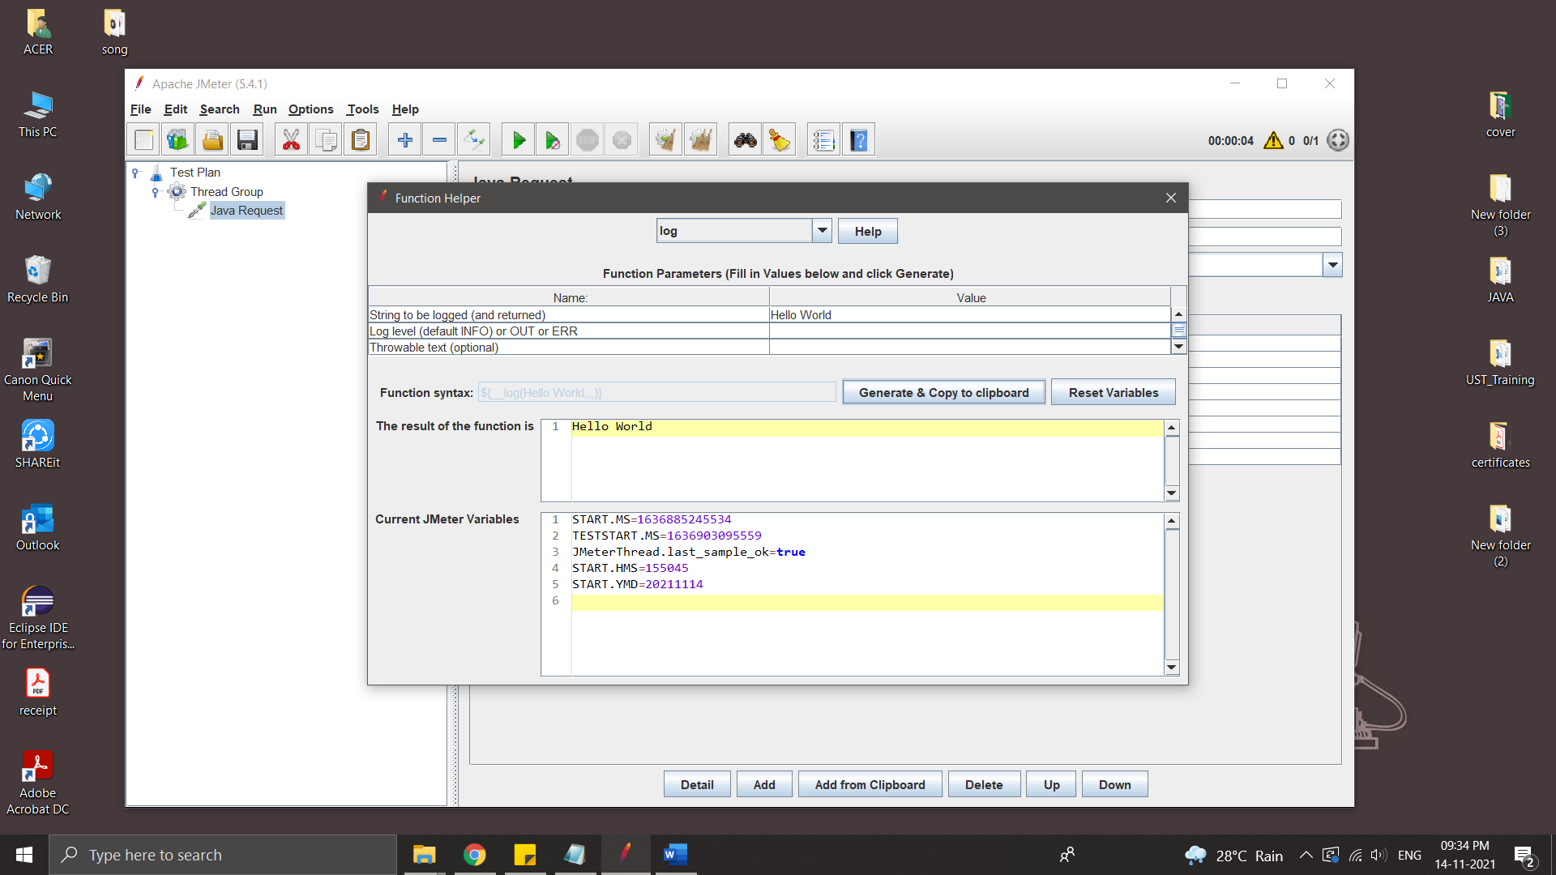

Paste it on Name of Java Request

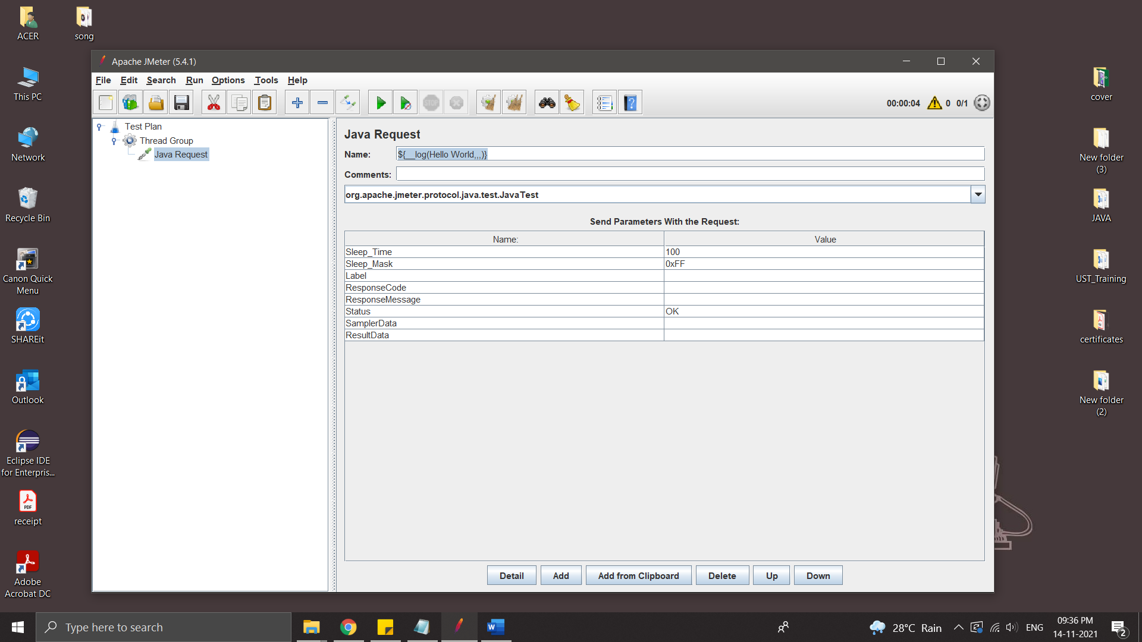

* Run

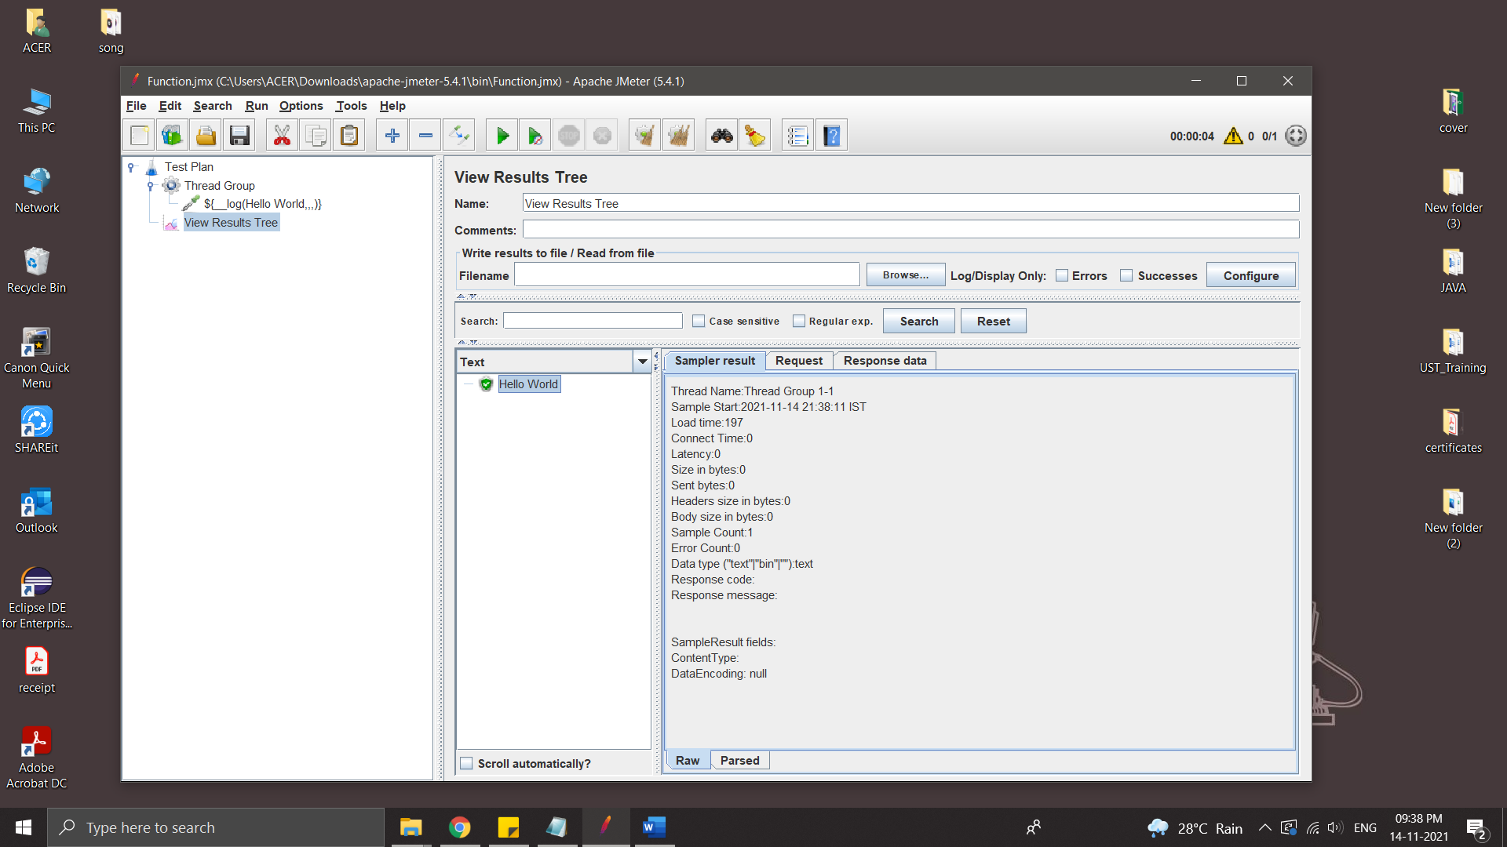

* Add some other function – time

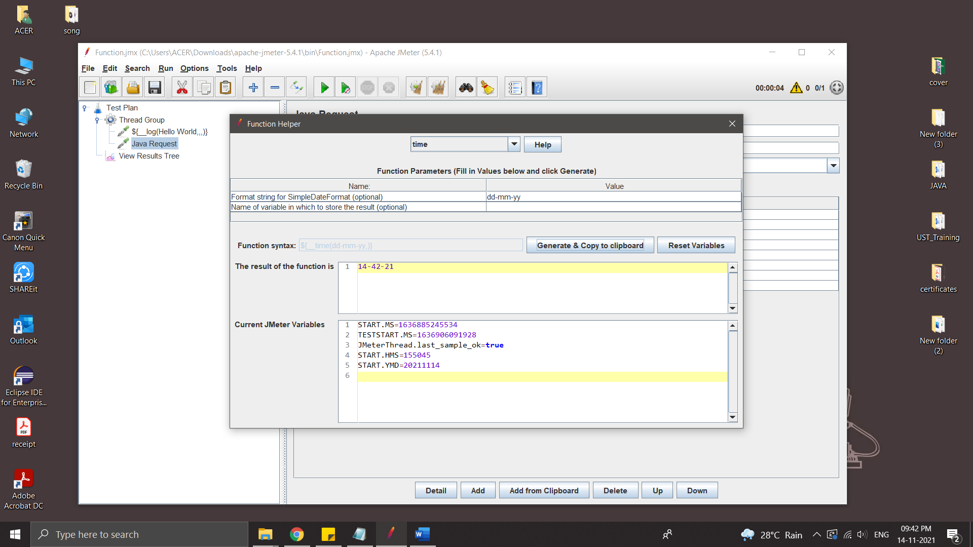

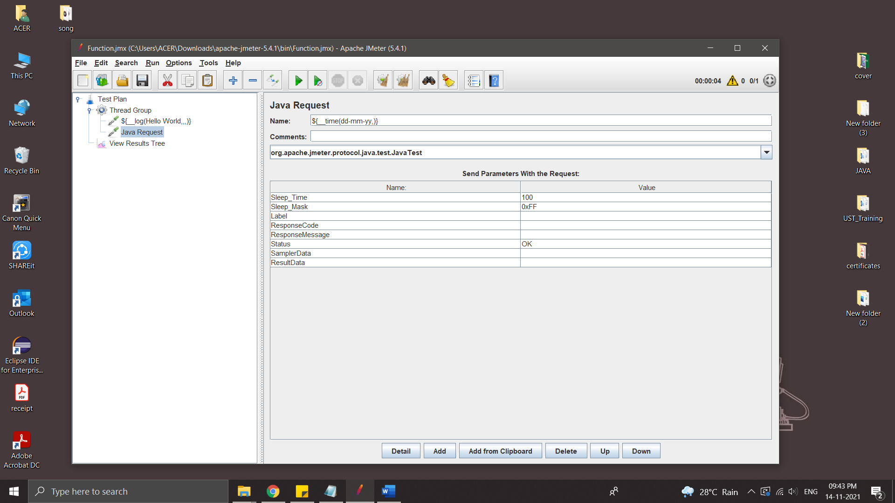

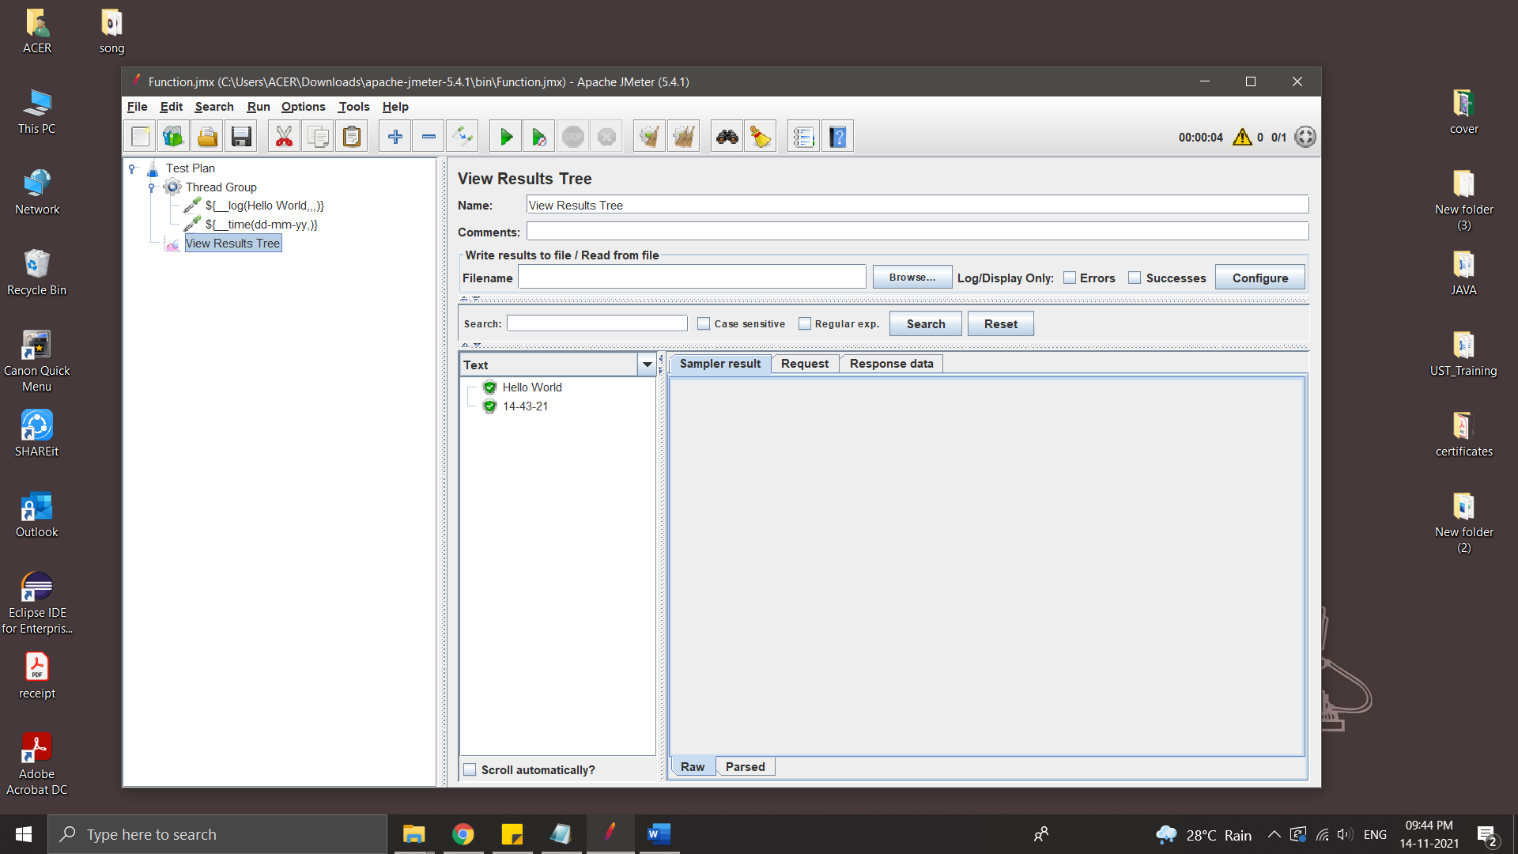

* ThreadNum – number of current thread

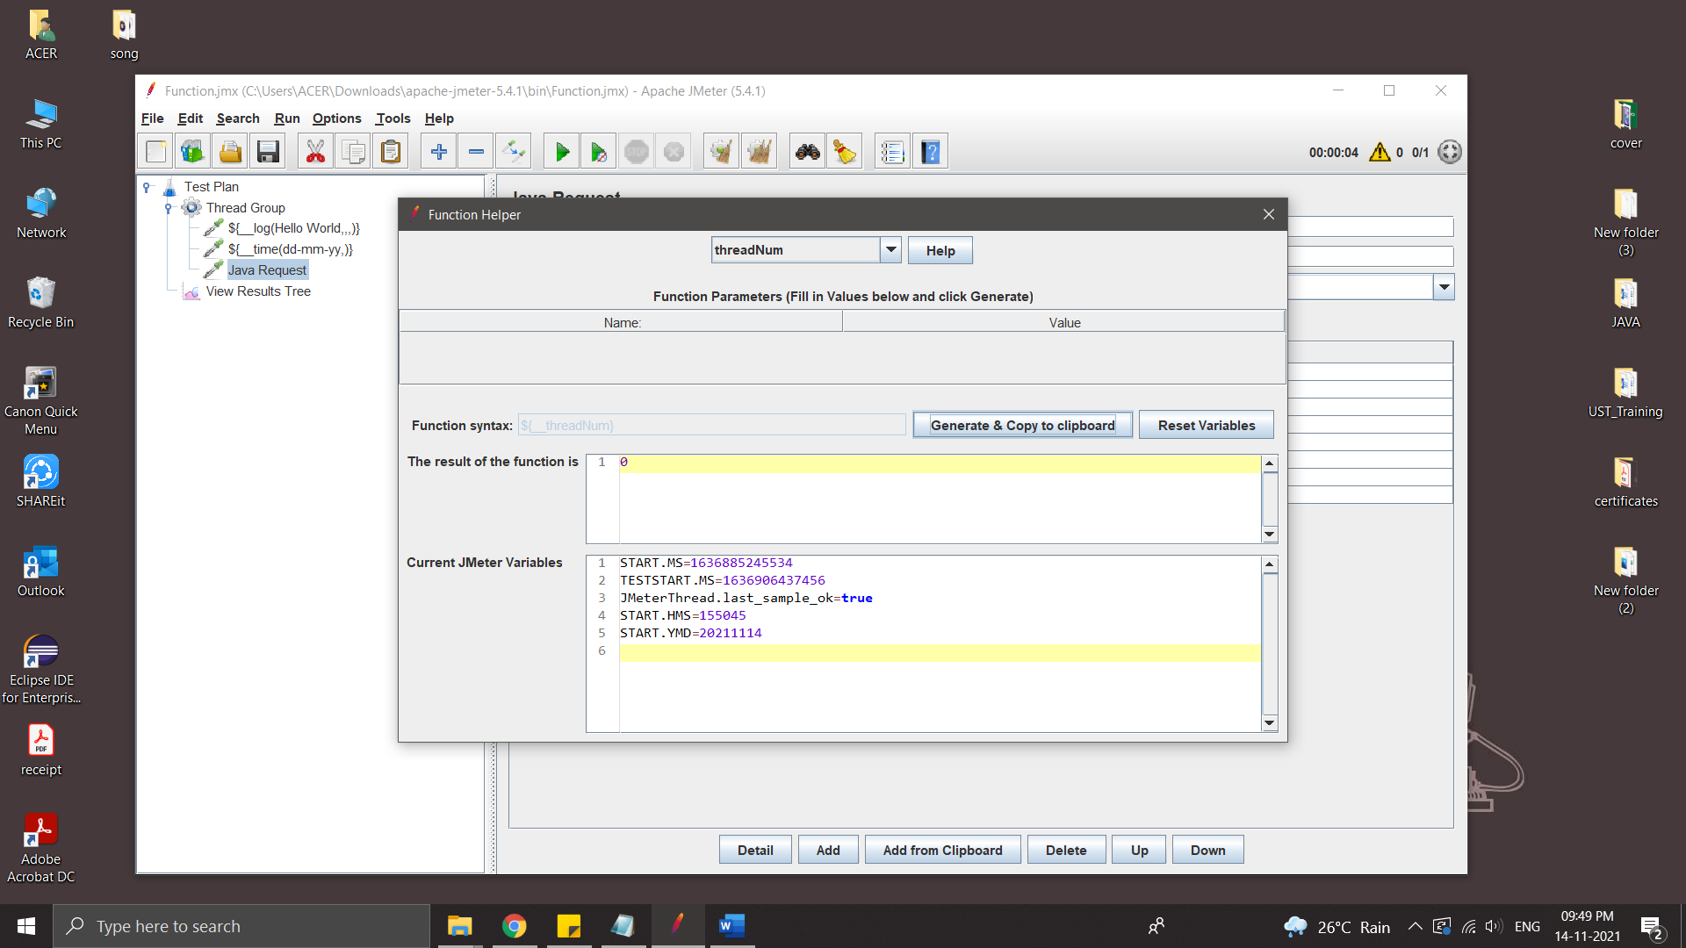

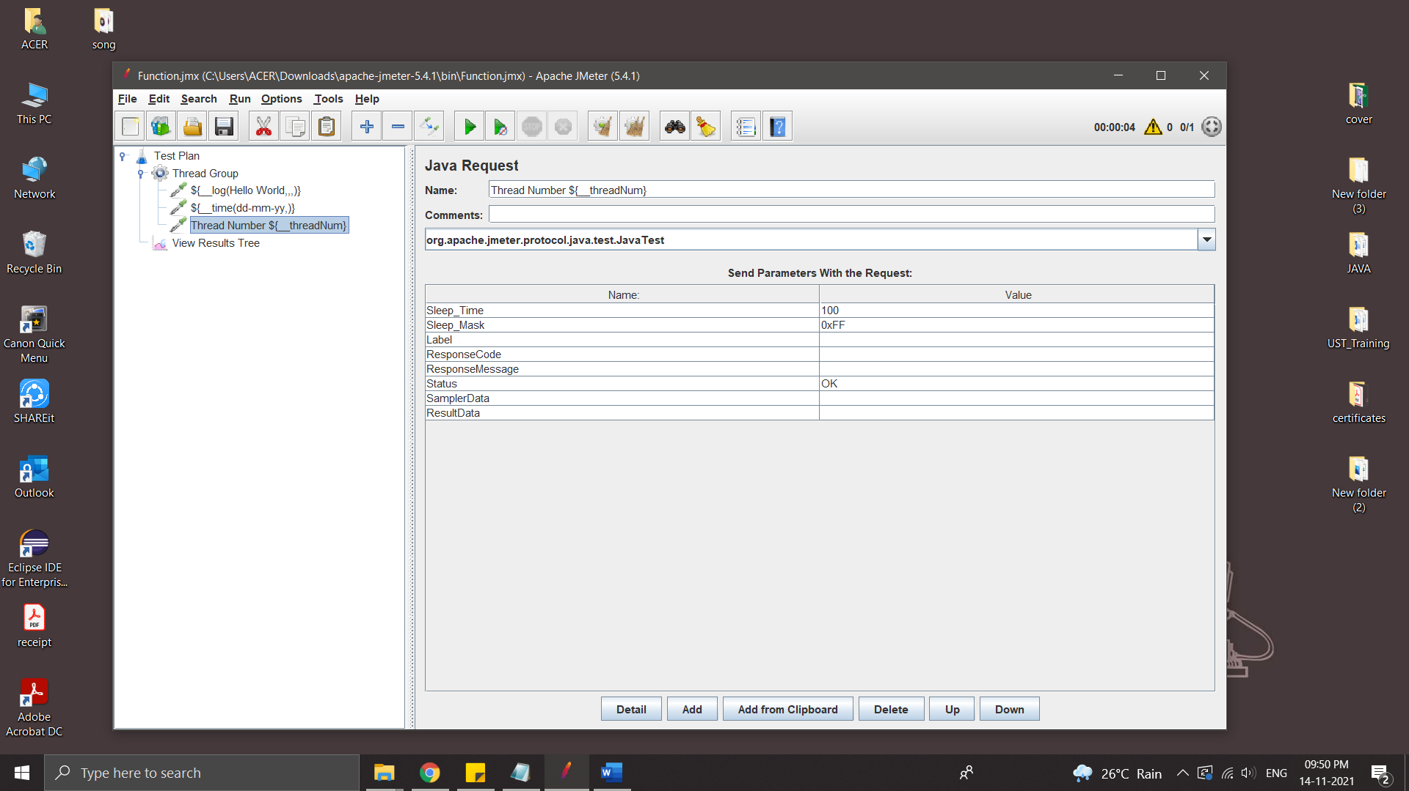

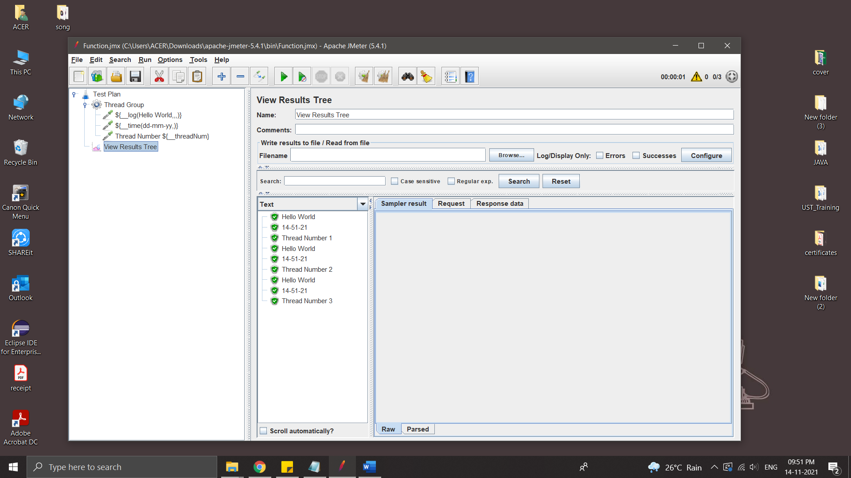

* IntSum - sum of number

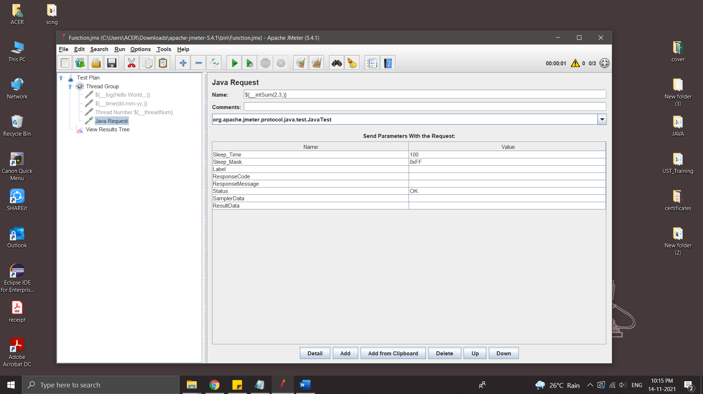

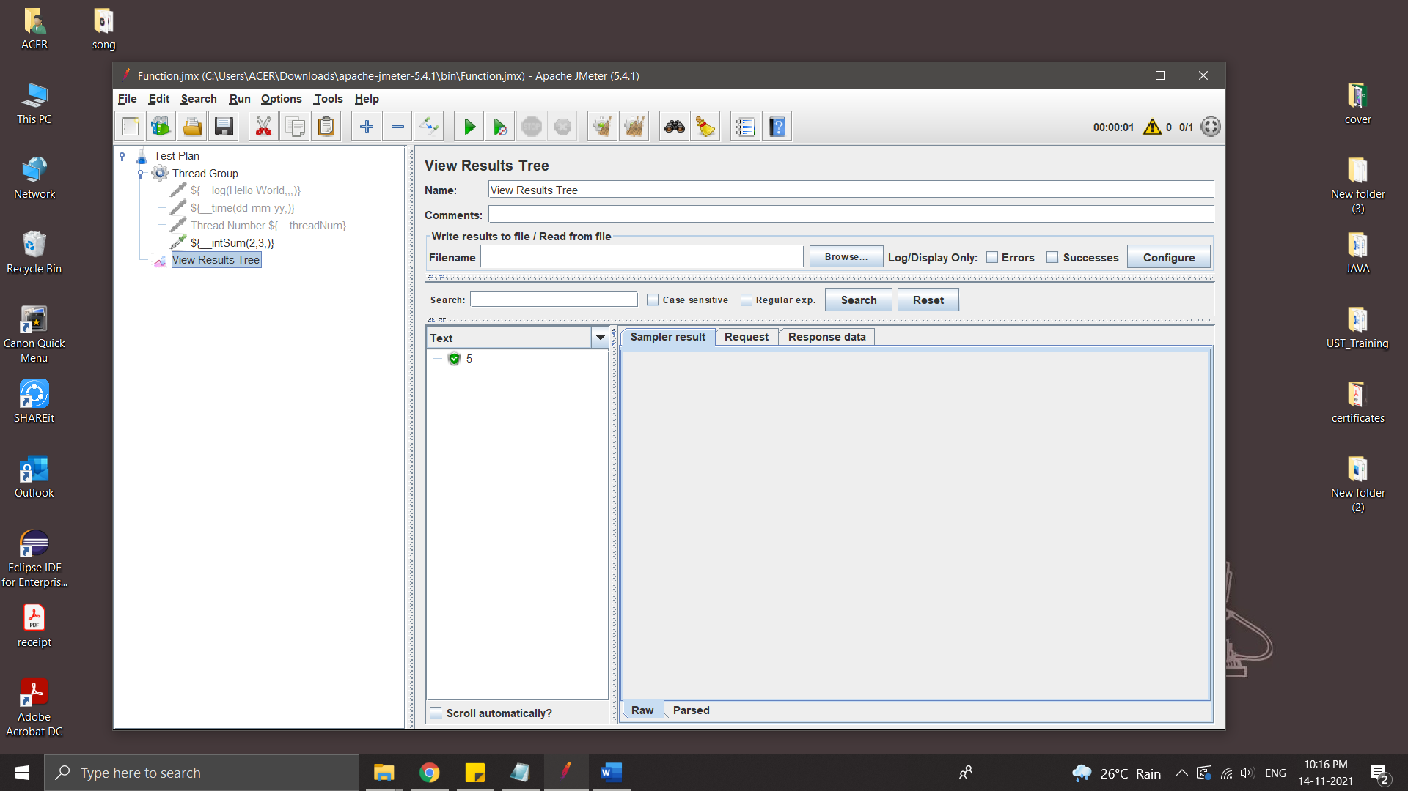

Store the result in variable

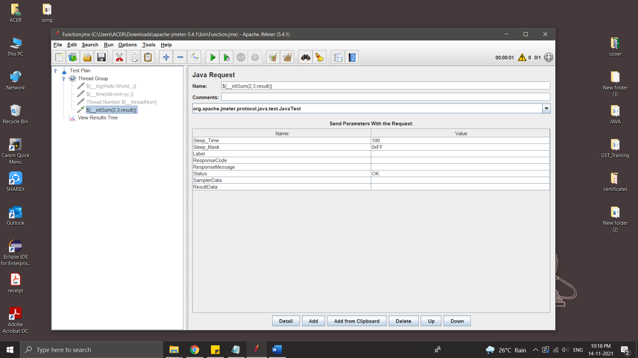

Variable can use in any where in this Thread Group

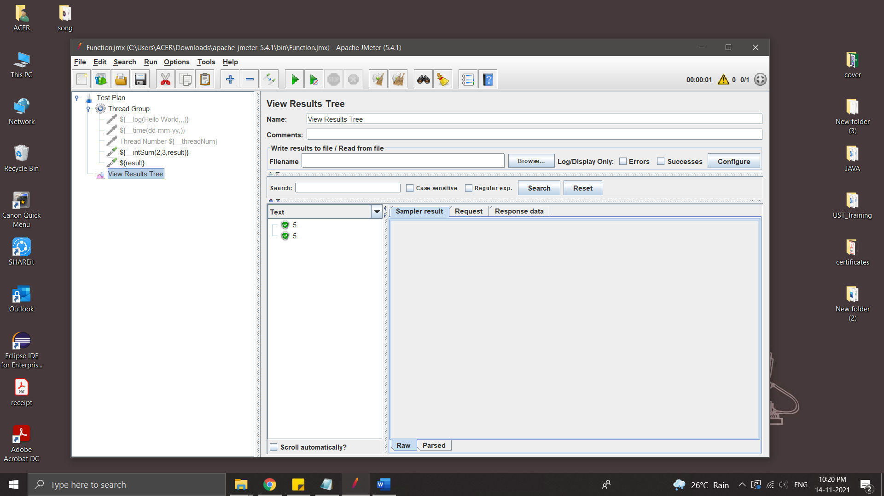

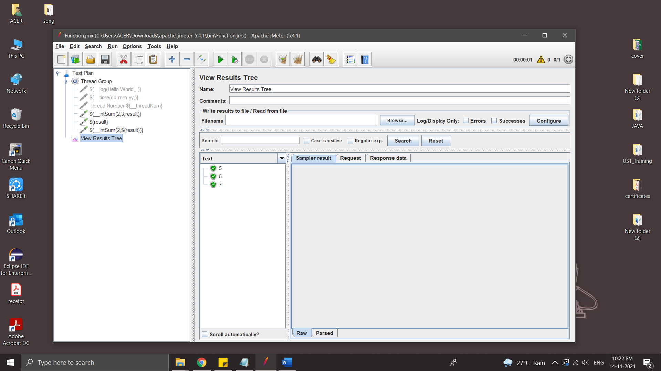

**HTML Report in JMeter**

HTML reports are very intuitive. Most of the time development team and upper management need this report to evaluate performance of a particular site or application.

Steps:

* Create a thread group
* Add some HTTP requests
* Add Listener
* Add Aggregate Reports

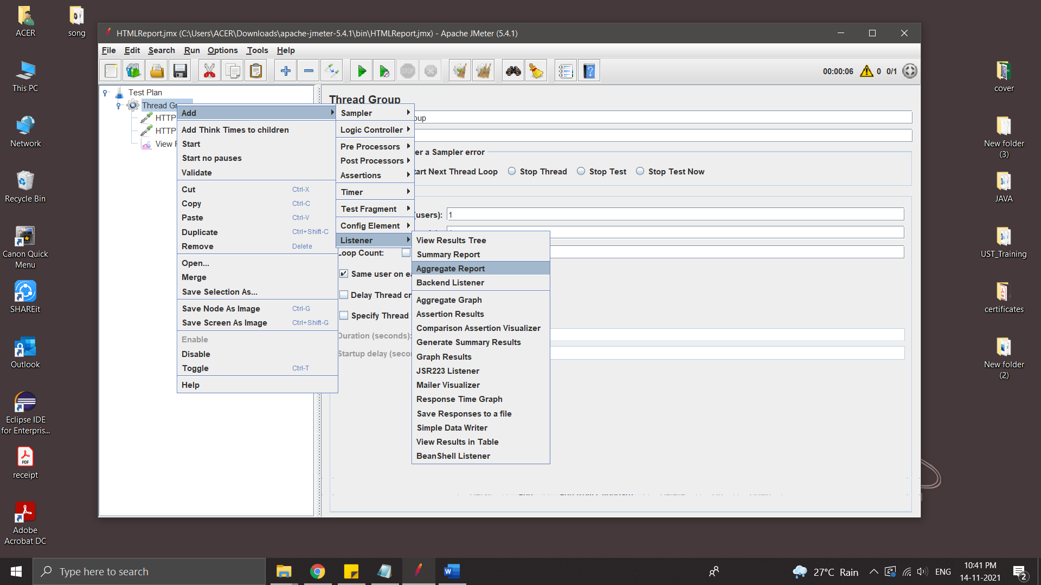

* Save and Run

All result are sored in Result.csv file

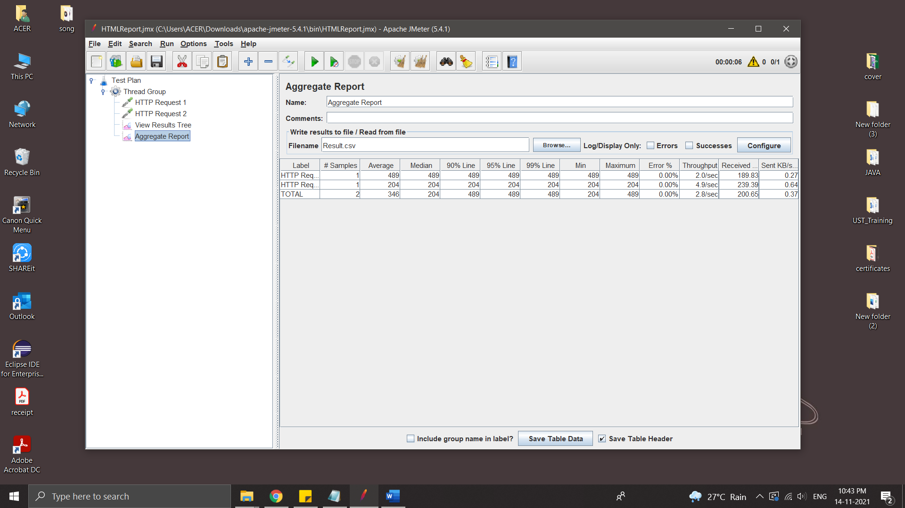

* Generate HTML report

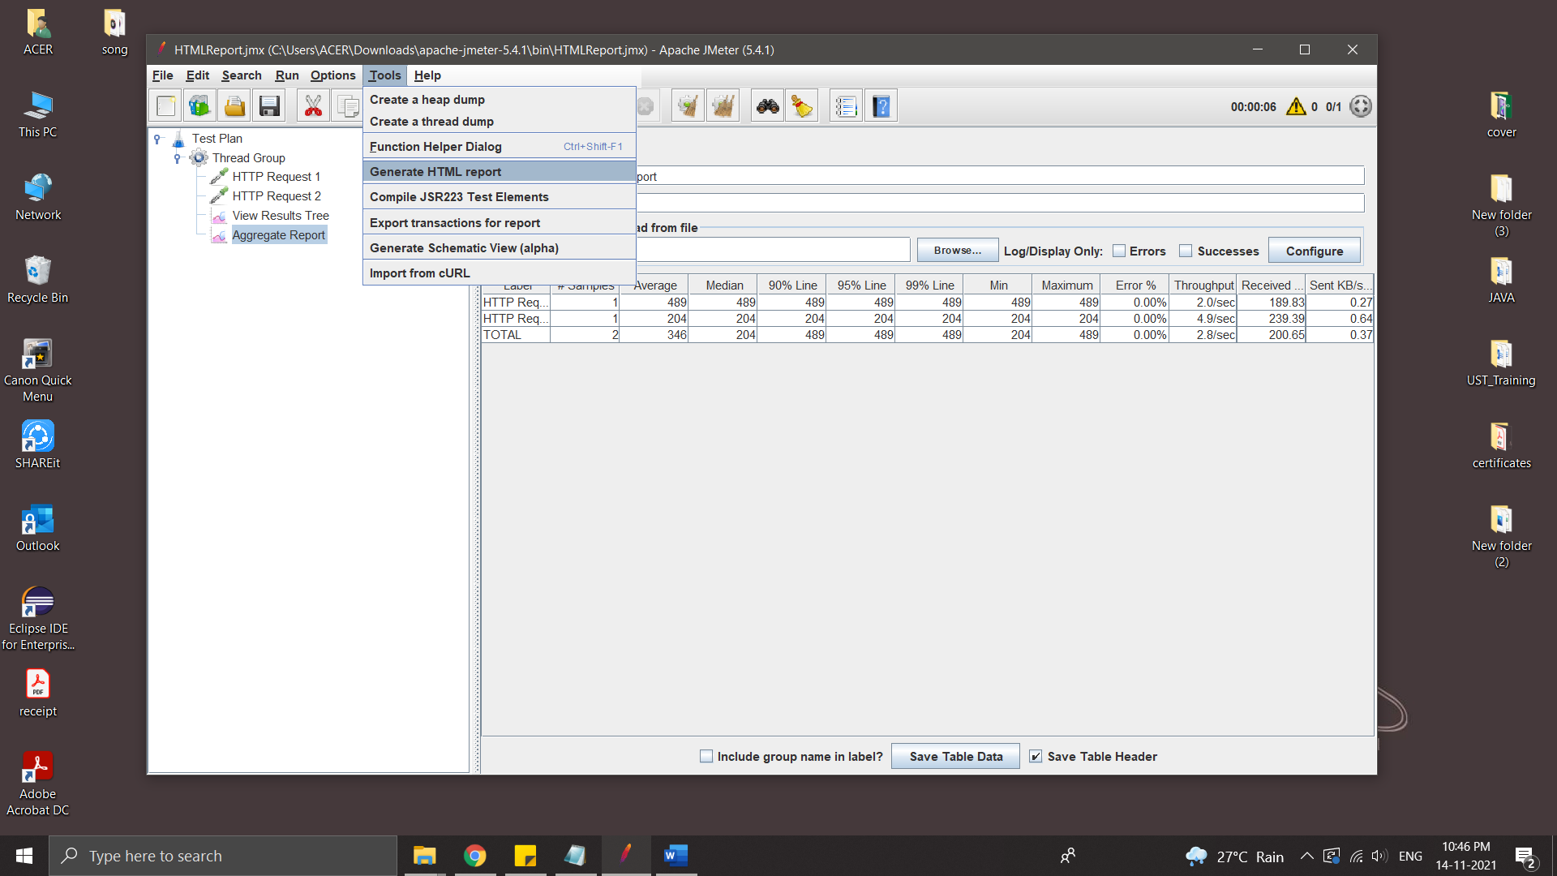

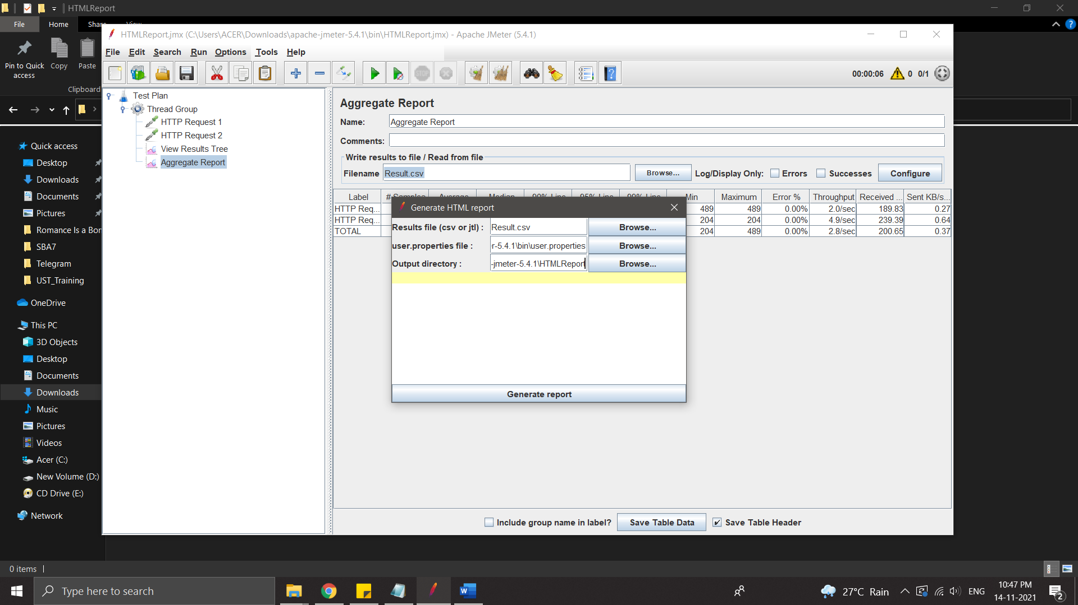

Output directory must be empty.

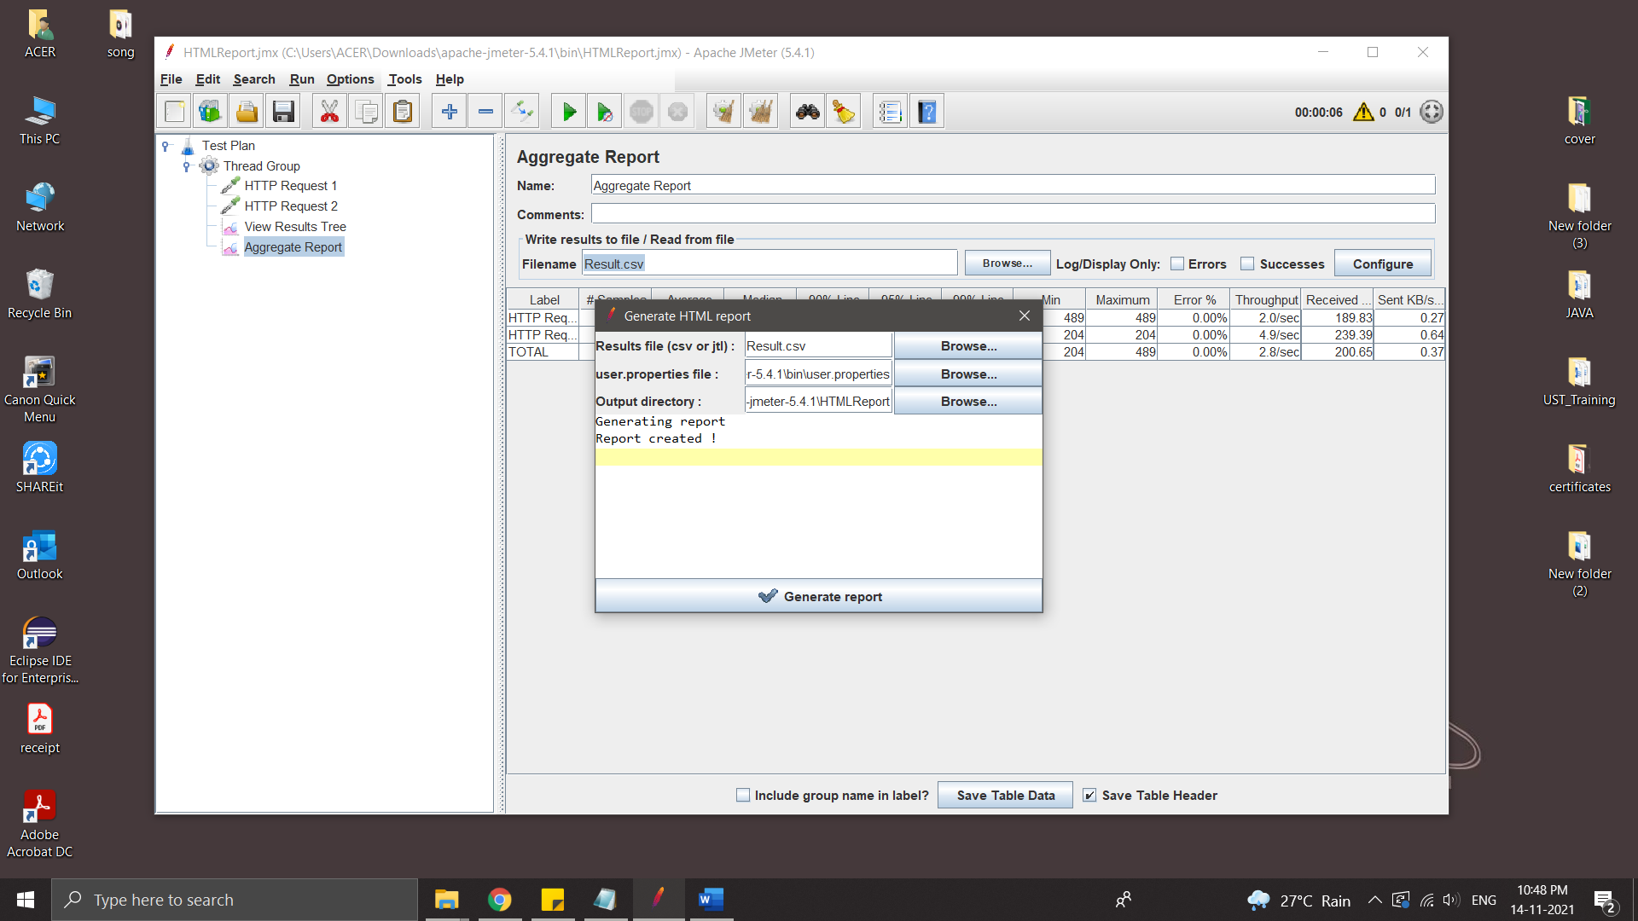

* Report

